What is an Audit Committee?
An audit committee is a group of board members responsible for overseeing an organization’s financial reporting, risk management, and other internal controls. These board members ensure financial statements are accurate and audits are conducted independently.
Composed of independent directors with relevant expertise, the audit committee acts as a key safeguard to ensure transparency, integrity, and accountability in a company’s financial operations. A compliance committee charter outlines the roles and responsibilities of these internal auditors, ensuring they uphold governance standards and remain ethical in their practices.

Audit Committee Structure
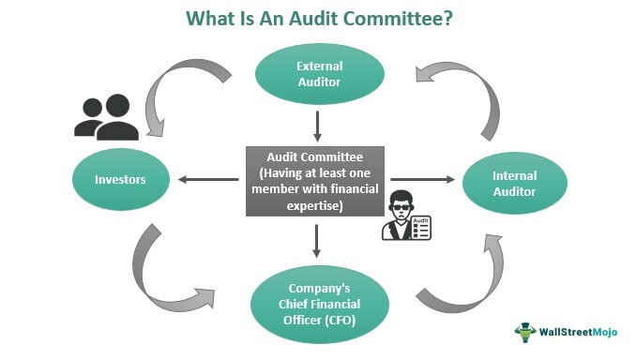
all audit committee members must be independent and prevent insiders from influencing the work of external and internal audit and the proceedings of the committee. The authorities review the committee's independence annually to ensure the members are working under no influence.
The committee members must comply with the financial literacy requirements of the relevant securities exchange.
In addition, at least one member must be a financial expert. Having this expert ensures that the committee effectively assesses every financial aspect of a company, both legally and technically.
- The committee must comprise at least three members who are of non-executive background.
- Preferably, they must be independent members who shall show no leniency or allow any lapses in terms of ethical or moral gaps in the accounting of the company.
- The chair of the committee must be independent and cannot be the chair of the board of directors.
- It is compulsory for at least one member to have relevant qualification and experience in the field of finance and accounting.
- Occasionally, non-committee members would be invited to take part in the meetings if the chair of the committee thinks it is appropriate.

Audit Committee Responsibilities
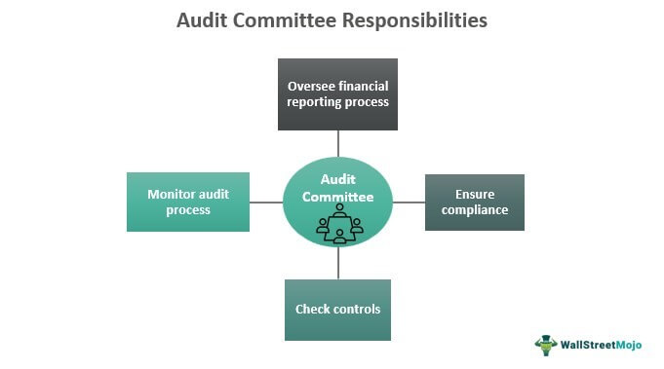
Understanding the responsibilities of an audit committee is crucial for ensuring financial transparency and accountability in an organization. Those responsibilities include:

Financial Audit Reporting
Audit committees are responsible for reviewing and assessing the integrity of the company’s financial statement by scrutinizing its accounting practices and operations. They thoroughly review the financial reports prepared by management, including the balance sheet, income statement, cash flow statement, and accompanying notes.
In addition to verifying the accuracy of the financial reports, audit committees also assess their completeness. They ensure all necessary disclosures, like information about transactions, contingencies, related party transactions, and significant accounting policies, are appropriately presented.

2. Internal Control and Risk Management
Audit committees are responsible for reviewing the company’s internal control systems to ensure they effectively mitigate risks. This includes collaborating with the risk committee in accordance with the risk committee charter to evaluate and implement strategies that address operational, financial, and compliance risks.

3. Compliance and Regulatory Controls
Audit committees ensure the organization operates within the legal and ethical framework, adhering to applicable regulations and industry guidelines. The committee members review compliance programs to assess their effectiveness and identify any gaps or areas of improvement.
Audit committees also stay abreast of regulatory changes and assess their impact on the organization. They monitor developments in laws and regulations relevant to the company’s industry and operations.

4. Whistleblower and Ethics Programs
Audit committees establish mechanisms to enable employees and stakeholders to report concerns regarding accounting practices, fraud, or ethical violations. The audit committee oversees the effectiveness of these programs and ensures they provide a safe and confidential environment for reporting.
As part of their oversight, audit committees review reports of alleged misconduct or violations received through the whistleblower and ethics programs. They assess the nature and significance of these issues and determine the appropriate course of action, which may involve initiating investigations or engaging external resources, such as forensic auditors or legal counsel.

