UNIT-III
Machine Learning

Decision Tree
Let’s consider a decision tree for predicting whether a customer will buy a product based on age, income and previous purchases: Here's how the decision tree works:
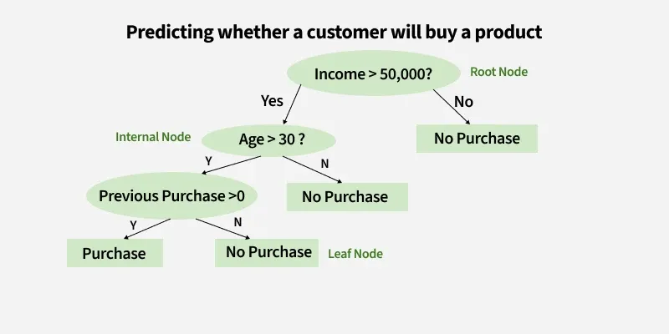
1. Root Node (Income)
First Question: "Is the person’s income greater than $50,000?"
- If Yes, proceed to the next question.
- If No, predict "No Purchase" (leaf node).
2. Internal Node (Age):
If the person’s income is greater than $50,000, ask: "Is the person’s age above 30?"
- If Yes, proceed to the next question.
- If No, predict "No Purchase" (leaf node).
3. Internal Node (Previous Purchases):
- If the person is above 30 and has made previous purchases, predict "Purchase" (leaf node).
- If the person is above 30 and has not made previous purchases, predict "No Purchase" (leaf node).
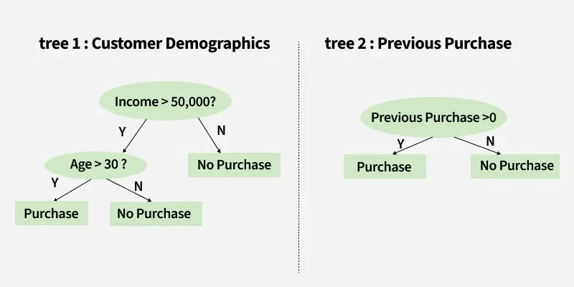Decision making with 2 Decision Tree
Example: Predicting Whether a Customer Will Buy a Product Using Two Decision Trees
Tree 1: Customer Demographics
First tree asks two questions:
1. "Income > $50,000?"
- If Yes, Proceed to the next question.
- If No, "No Purchase"
2. "Age > 30?"
- Yes: "Purchase"
- No: "No Purchase"
Tree 2: Previous Purchases
"Previous Purchases > 0?"
- Yes: "Purchase"
- No: "No Purchase"
Once we have predictions from both trees, we can combine the results to make a final prediction. If Tree 1 predicts "Purchase" and Tree 2 predicts "No Purchase", the final prediction might be "Purchase" or "No Purchase" depending on the weight or confidence assigned to each tree. This can be decided based on the problem context.
Information Gain and Gini Index in Decision Tree
Till now we have discovered the basic intuition and approach of how decision tree works, so lets just move to the attribute selection measure of decision tree. We have two popular attribute selection measures used:
1. Information Gain
Information Gain tells us how useful a question (or feature) is for splitting data into groups. It measures how much the uncertainty decreases after the split. A good question will create clearer groups and the feature with the highest Information Gain is chosen to make the decision.
For example if we split a dataset of people into "Young" and "Old" based on age and all young people bought the product while all old people did not, the Information Gain would be high because the split perfectly separates the two groups with no uncertainty left
- Suppose SS is a set of instances AA is an attribute, SvSv is the subset of SS, vv represents an individual value that the attribute AA can take and Values (AA) is the set of all possible values of AA then
Gain(S,A)=Entropy(S)−∑vA∣Sv∣∣S∣.Entropy(Sv)Gain(S,A)=Entropy(S)−∑vA​∣S∣∣Sv​∣​.Entropy(Sv​)
- Entropy: It is the measure of uncertainty of a random variable, it characterizes the impurity of an arbitrary collection of examples. The higher the entropy more the information content.
For example if a dataset has an equal number of "Yes" and "No" outcomes (like 3 people who bought a product and 3 who didn’t), the entropy is high because it’s uncertain which outcome to predict. But if all the outcomes are the same (all "Yes" or all "No") the entropy is 0 meaning there is no uncertainty left in predicting the outcome
Suppose SS is a set of instances, AA is an attribute, SvSv is the subset of SS with AA= vv and Values (AA) is the set of all possible values of AA, then
Gain(S,A)=Entropy(S)−∑vϵValues(A)∣Sv∣∣S∣.Entropy(Sv) Gain(S,A)=Entropy(S)−∑vϵValues(A)​∣S∣∣Sv​∣​.Entropy(Sv​)
Example:
For the set X = {a,a,a,b,b,b,b,b}
Total instances: 8
Instances of b: 5
Instances of a: 3
Entropy H(X)=[(38)log⁡238+(58)log⁡258]=−[0.375(−1.415)+0.625(−0.678)]=−(−0.53−0.424)=0.954Entropy H(X)​=[(83​)log2​83​+(85​)log2​85​]=−[0.375(−1.415)+0.625(−0.678)]=−(−0.53−0.424)=0.954​
Building Decision Tree using Information Gain the essentials
- Start with all training instances associated with the root node
- Use info gain to choose which attribute to label each node with
- Recursively construct each subtree on the subset of training instances that would be classified down that path in the tree.
- If all positive or all negative training instances remain, the label that node “yes" or “no" accordingly
- If no attributes remain label with a majority vote of training instances left at that node
- If no instances remain label with a majority vote of the parent's training instances.
Example: Now let us draw a Decision Tree for the following data using Information gain. Training set: 3 features and 2 classes
X | Y | Z | C
1 | 1 | 1 | I
1 | 1 | 0 | I
0 | 0 | 1 | II
1 | 0 | 0 | II
Here, we have 3 features and 2 output classes. To build a decision tree using Information gain. We will take each of the features and calculate the information for each feature.
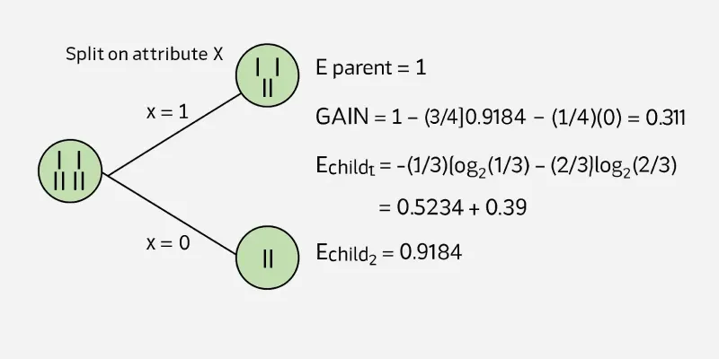Split on attribute X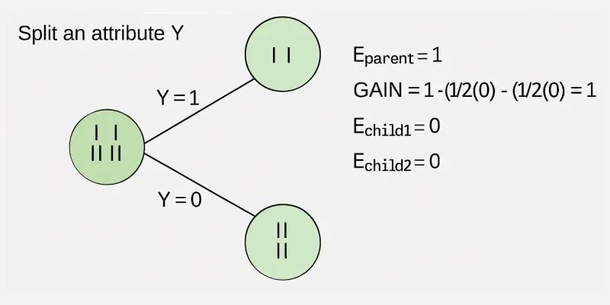Split on attribute YSplit on attribute Z
From the above images we can see that the information gain is maximum when we make a split on feature Y. So, for the root node best-suited feature is feature Y. Now we can see that while splitting the dataset by feature Y, the child contains a pure subset of the target variable. So we don't need to further split the dataset. The final tree for the above dataset would look like this: 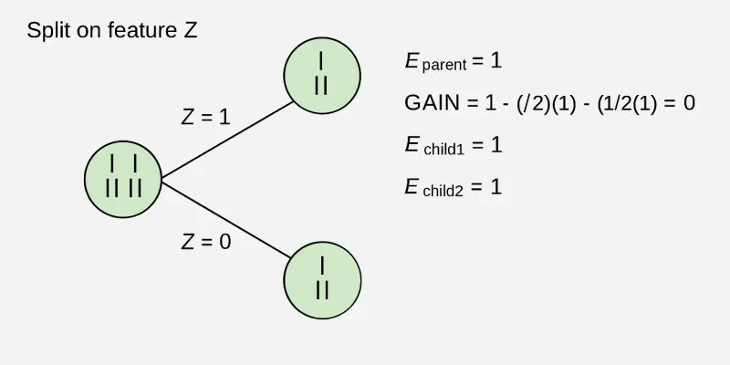
information gain on attribute Y
2. Gini Index
Gini Index is a metric to measure how often a randomly chosen element would be incorrectly identified. It means an attribute with a lower Gini index should be preferred. Sklearn supports “Gini” criteria for Gini Index and by default it takes “gini” value.
For example if we have a group of people where all bought the product (100% "Yes") the Gini Index is 0 indicate perfect purity. But if the group has an equal mix of "Yes" and "No" the Gini Index would be 0.5 show high impurity or uncertainty. Formula for Gini Index is given by :
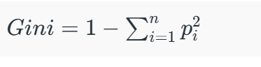
Some additional features of the Gini Index are:
- It is calculated by summing the squared probabilities of each outcome in a distribution and subtracting the result from 1.
- A lower Gini Index indicates a more homogeneous or pure distribution while a higher Gini Index indicates a more heterogeneous or impure distribution.
- In decision trees the Gini Index is used to evaluate the quality of a split by measuring the difference between the impurity of the parent node and the weighted impurity of the child nodes.
- Compared to other impurity measures like entropy, the Gini Index is faster to compute and more sensitive to changes in class probabilities.
- One disadvantage of the Gini Index is that it tends to favour splits that create equally sized child nodes, even if they are not optimal for classification accuracy.
- In practice the choice between using the Gini Index or other impurity measures depends on the specific problem and dataset and requires experimentation and tuning.
Understanding Decision Tree with Real life use case:
Till now we have understand about the attributes and components of decision tree. Now lets jump to a real life use case in which how decision tree works step by step.
Step 1. Start with the Whole Dataset
We begin with all the data which is treated as the root node of the decision tree.
Step 2. Choose the Best Question (Attribute)
Pick the best question to divide the dataset. For example ask: "What is the outlook?"
Possible answers: Sunny, Cloudy or Rainy.
Step 3. Split the Data into Subsets
Divide the dataset into groups based on the question:
- If Sunny go to one subset.
- If Cloudy go to another subset.
- If Rainy go to the last subset.
Step 4. Split Further if Needed (Recursive Splitting)
For each subset ask another question to refine the groups. For example If the Sunny subset is mixed ask: "Is the humidity high or normal?"
- High humidity → "Swimming".
- Normal humidity → "Hiking".
Step 5. Assign Final Decisions (Leaf Nodes)
When a subset contains only one activity, stop splitting and assign it a label:
- Cloudy → "Hiking".
- Rainy → "Stay Inside".
- Sunny + High Humidity → "Swimming".
- Sunny + Normal Humidity → "Hiking".
Step 6. Use the Tree for Predictions
To predict an activity follow the branches of the tree. Example: If the outlook is Sunny and the humidity is High follow the tree:
- Start at Outlook.
- Take the branch for Sunny.
- Then go to Humidity and take the branch for High Humidity.
- Result: "Swimming".
A decision tree works by breaking down data step by step asking the best possible questions at each point and stopping once it reaches a clear decision. It's an easy and understandable way to make choices. Because of their simple and clear structure decision trees are very helpful in machine learning for tasks like sorting data into categories or making predictions.

Impurity measures:
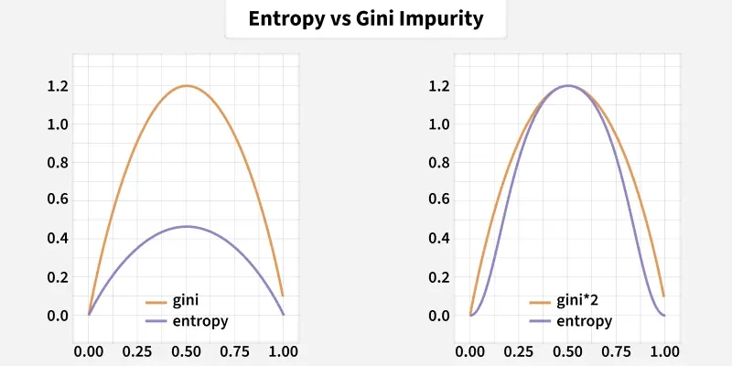
Impurity measures are mathematical metrics used in decision tree algorithms to evaluate the homogeneity of data within nodes, guiding optimal splits by maximizing purity (reducing disorder). Common measures include Gini Impurity (0-0.5), Entropy (0-1), and Misclassification Rate. They range from zero (pure) to a maximum (maximum disorder).

Key Impurity Measures
- Gini Impurity: Measures the likelihood of an incorrect classification of a new instance. It is calculated as, where Pi
is the probability of an object being classified into a particular class. Gini is generally faster to compute as it requires no logarithmic calculations.
- Entropy: Based on information theory, this measures the disorder or uncertainty in the data. It is calculated as 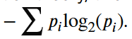 It often produces slightly better results than Gini but is computationally more expensive.
- Misclassification Rate: Measures the fraction of records that would be wrongly classified if a node were labeled with the majority class.
- Gain Ratio: Used to address the tendency of entropy and Gini to favor attributes with a large number of distinct values by penalizing such splits.
How They Work
- Calculate Initial Impurity: The impurity of the parent node is computed.
- Evaluate Splits: Potential splits for each feature are evaluated by calculating the impurity of resulting child nodes.
- Minimize Impurity: The algorithm selects the feature and threshold that minimize the weighted average impurity of the child nodes.
Comparison
- A perfectly pure node (all instances from one class) has a Gini index of 0 and Entropy of 0.
- A perfectly mixed node (equal representation of classes) results in high Gini (approaching 0.5) or high Entropy (approaching 1).
- Gini is preferred for large datasets due to efficiency, while both provide similar results.
Scenario | Gini Impurity | Entropy
Training Speed | Faster computation since it avoids log operations | Slightly slower due to logarithmic calculations
Split Behavior | Creates splits quickly, favoring dominant classes | Produces more balanced node partitions
Dataset Size | Efficient for large, high-dimensional datasets | Useful for structured datasets with balanced classes
Sensitivity to Distribution | Less sensitive to small probability changes | More sensitive to subtle probability differences
Common Usage | Often default in libraries like CART | Preferred when theoretical information gain matte

Implementing Decision Tree Regression using Scikit-Learn
A Decision Tree Regressor is used to predict continuous values such as prices or scores using a tree-like structure. It splits the data into smaller groups based on simple rules derived from input features, helping reduce prediction errors. At the end of each branch, called a leaf node, the model outputs a value, i.e usually the average of that group.
For example, to predict house prices using features like size, location, and age, the tree may first split by location, then by size and finally by age. Let’s implement it:
Step 1: Importing the required libraries
We will import the following libraries.
- NumPy: For numerical computations and array handling
- Matplotlib: For plotting graphs and visualizations
- We import different modules from scikit-learn for various tasks such as modeling, data splitting, tree visualization and performance evaluation.
import numpy as np
import matplotlib.pyplot as plt
from sklearn.tree import DecisionTreeRegressor, export_text
from sklearn.model_selection import train_test_split
from sklearn.metrics import mean_squared_error
Step 2: Creating a Sample Dataset
Here we create a synthetic dataset using numpy library, where the feature values X are randomly sampled and sorted between 0 and 5 and the target y is a noisy sine function of X. The scatter plot visualizes the data points, showing how the target values vary with the feature.
np.random.seed(42)
X = np.sort(5 * np.random.rand(100, 1), axis=0)
y = np.sin(X).ravel() + np.random.normal(0, 0.1, X.shape[0])

plt.scatter(X, y, color='red', label='Data')
plt.title("Synthetic Dataset")
plt.xlabel("Feature")
plt.ylabel("Target")
plt.legend()
plt.show()
Output:
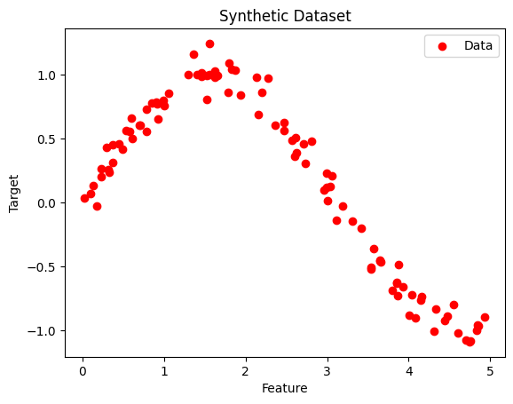Non-linear Data
Step 3: Splitting the Dataset
We split the dataset into train and test dataset using the train_test_split function into the ratio of 70% training and 30% testing. We also set a random_state=42 to ensure reproducibility.
X_train, X_test, y_train, y_test = train_test_split(X, y, test_size=0.3, random_state=42)
Step 4: Initializing the Decision Tree Regressor
Here we used DecisionTreeRegressor method from Sklearn python library to implement Decision Tree Regression. We also define the max_depth as 4 which controls the maximum levels a tree can reach , controlling model complexity.
regressor = DecisionTreeRegressor(max_depth=4, random_state=42)
Step 5: Fiting Decision Tree Regressor Model
We fit our model using the .fit() method on the X_train and y_train, so that the model can learn the relationships between different variables.
regressor.fit(X_train, y_train)
Output:
DecisionTreeRegressor(max_depth=4, random_state=42)
Step 6: Predicting a New Value
We will now predict a new value using our trained model using the predict() function. After that we also calculated the mean squared error (MSE) to check how accurate is our predicted value from the actual value , telling how well the model fits to our training data.
y_pred = regressor.predict(X_test)

mse = mean_squared_error(y_test, y_pred)
print(f"Mean Squared Error: {mse:.4f}")
Output:
Mean Squared Error: 0.0151
Step 7: Visualizing the result
We will visualise the regression line our model has calculated to see how well the decision tree fits the data and captures the underlying pattern, especially showing how the predictions change smoothly or in steps depending on the tree's splits.
X_grid = np.arange(min(X), max(X), 0.01)[:, np.newaxis]
y_grid_pred = regressor.predict(X_grid)

plt.figure(figsize=(10, 6))
plt.scatter(X, y, color='red', label='Data')
plt.plot(X_grid, y_grid_pred, color='blue', label='Model Prediction')
plt.title("Decision Tree Regression")
plt.xlabel("Feature")
plt.ylabel("Target")
plt.legend()
plt.show()
Output:
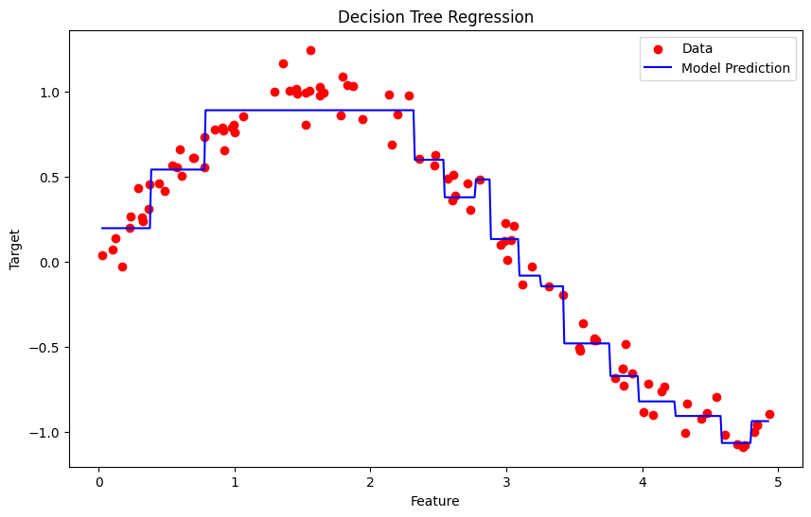Decision Tree Regression
Step 8: Export and Show the Tree Structure below
For better understanding we used plot_tree to visualize the structure of the decision tree to understand how the model splits the feature space, showing the decision rules at each node and how the tree partitions the data to make predictions.
from sklearn.tree import plot_tree

plt.figure(figsize=(20, 10))
plot_tree(
regressor,
feature_names=["Feature"],
filled=True,
rounded=True,
fontsize=10
)
plt.title("Decision Tree Structure")
plt.show()
Output:
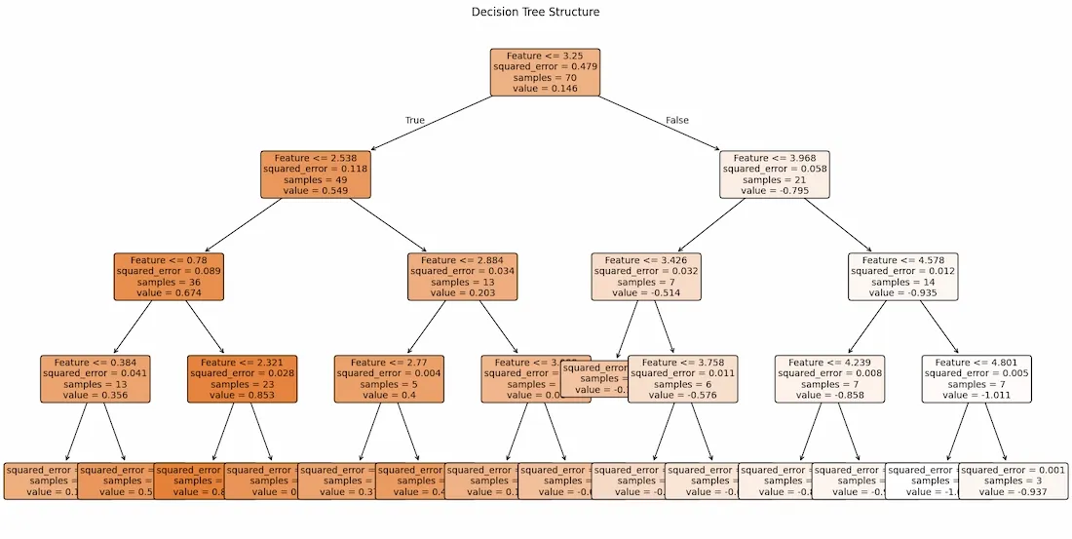Visualized Decision Tree Regression
Decision Tree Regression is used for predicting continuous values effectively capturing non-linear patterns in data. Its tree-based structure makes model interpretability easy as we can tell why a decision was made and why we get this specific output. This information can further be used to fine tune model based on it flow of working.
Bias-Variance Trade Off - Machine Learning
It is important to understand prediction errors (bias and variance) when it comes to accuracy in any machine-learning algorithm. There is a tradeoff between a model’s ability to minimize bias and variance which is referred to as the best solution for selecting a value of Regularization constant. A proper understanding of these errors would help to avoid the overfitting and underfitting of a data set while training the algorithm.
What is Bias?
The bias is known as the difference between the prediction of the values by the Machine Learning model and the correct value. Being high in biasing gives a large error in training as well as testing data. It recommended that an algorithm should always be low-biased to avoid the problem of underfitting. By high bias, the data predicted is in a straight line format, thus not fitting accurately in the data in the data set. Such fitting is known as the Underfitting of Data. This happens when the hypothesis is too simple or linear in nature. Refer to the graph given below for an example of such a situation.
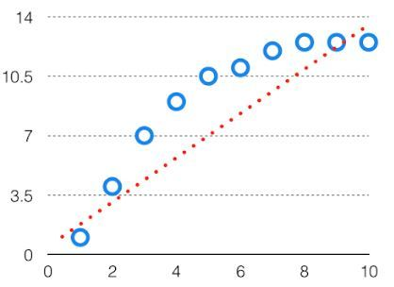High Bias in the Model
In such a problem, a hypothesis looks like follows.
hθ(x)=g(θ0+θ1x1+θ2x2) hθ​(x)=g(θ0​+θ1​x1​+θ2​x2​)
What is Variance?
The variability of model prediction for a given data point which tells us the spread of our data is called the variance of the model. The model with high variance has a very complex fit to the training data and thus is not able to fit accurately on the data which it hasn’t seen before. As a result, such models perform very well on training data but have high error rates on test data. When a model is high on variance, it is then said to as Overfitting of Data. Overfitting is fitting the training set accurately via complex curve and high order hypothesis but is not the solution as the error with unseen data is high. While training a data model variance should be kept low. The high variance data looks as follows.
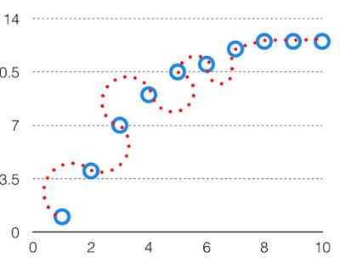High Variance in the Model
In such a problem, a hypothesis looks like follows.
hθ(x)=g(θ0+θ1x+θ2x2+θ3x3+θ4x4)hθ​(x)=g(θ0​+θ1​x+θ2​x2+θ3​x3+θ4​x4)
Bias Variance Tradeoff
If the algorithm is too simple (hypothesis with linear equation) then it may be on high bias and low variance condition and thus is error-prone. If algorithms fit too complex (hypothesis with high degree equation) then it may be on high variance and low bias. In the latter condition, the new entries will not perform well. Well, there is something between both of these conditions, known as a Trade-off or Bias Variance Trade-off. This tradeoff in complexity is why there is a tradeoff between bias and variance. An algorithm can’t be more complex and less complex at the same time. For the graph, the perfect tradeoff will be like this.
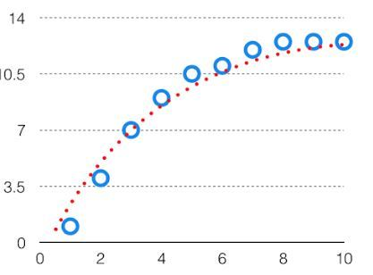
We try to optimize the value of the total error for the model by using the Bias-Variance Tradeoff.
TotalError=Bias²+Variance+IrreducibleErrorTotalError=Bias²+Variance+IrreducibleError
The best fit will be given by the hypothesis on the tradeoff point. The error to complexity graph to show trade-off is given as -
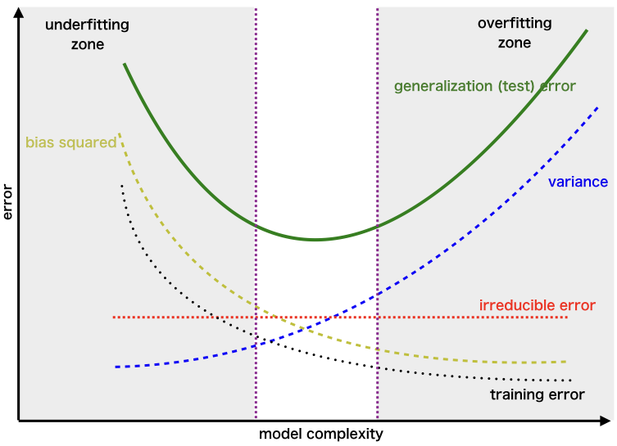Region for the Least Value of Total Error
This is referred to as the best point chosen for the training of the algorithm which gives low error in training as well as testing data.

Random Forest Algorithm in Machine Learning
Random Forest is a machine learning algorithm that uses many decision trees to make better predictions. Each tree looks at different random parts of the data and their results are combined by voting for classification or averaging for regression which makes it as ensemble learning technique. This helps in improving accuracy and reducing errors.
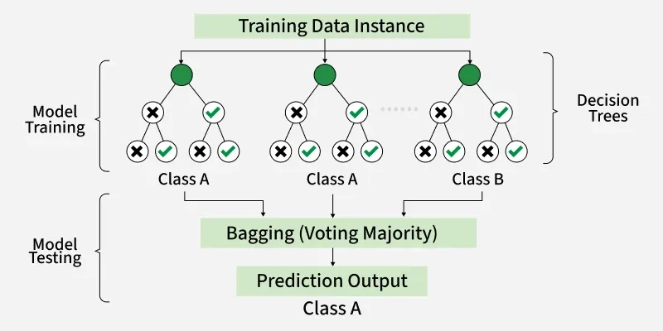
Working of Random Forest Algorithm
- Create Many Decision Trees: The algorithm makes many decision trees each using a random part of the data. So every tree is a bit different.
- Pick Random Features: When building each tree it doesn’t look at all the features (columns) at once. It picks a few at random to decide how to split the data. This helps the trees stay different from each other.
- Each Tree Makes a Prediction: Every tree gives its own answer or prediction based on what it learned from its part of the data.
- Combine the Predictions: For classification we choose a category as the final answer is the one that most trees agree on i.e majority voting and for regression we predict a number as the final answer is the average of all the trees predictions.
- Why It Works Well: Using random data and features for each tree helps avoid overfitting and makes the overall prediction more accurate and trustworthy.
Key Features of Random Forest
- Handles Missing Data: It can work even if some data is missing so you don’t always need to fill in the gaps yourself.
- Shows Feature Importance: It tells you which features (columns) are most useful for making predictions which helps you understand your data better.
- Works Well with Big and Complex Data: It can handle large datasets with many features without slowing down or losing accuracy.
- Used for Different Tasks: You can use it for both classification like predicting types or labels and regression like predicting numbers or amounts.

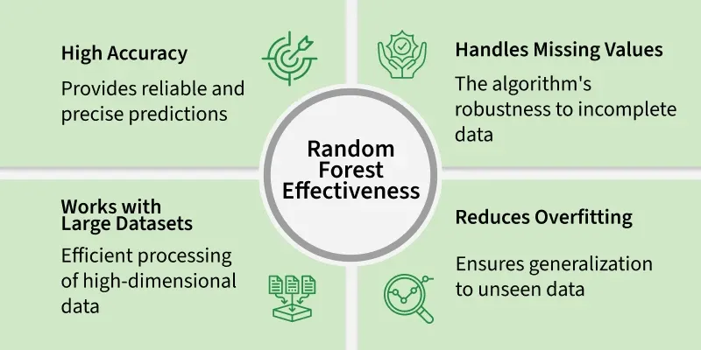
Assumptions of Random Forest
- Each tree makes its own decisions: Every tree in the forest makes its own predictions without relying on others.
- Random parts of the data are used: Each tree is built using random samples and features to reduce mistakes.
- Enough data is needed: Sufficient data ensures the trees are different and learn unique patterns and variety.
- Different predictions improve accuracy: Combining the predictions from different trees leads to a more accurate final result.
Implementing Random Forest for Classification Tasks
Here we will predict survival rate of a person in titanic.
You can download dataset from here.
- Import libraries like pandas and scikit learn.
- Load the Titanic dataset.
- Remove rows with missing target values ('Survived').
- Select features like class, sex, age, etc and convert 'Sex' to numbers.
- Fill missing age values with the median.
- Split the data into training and testing sets, then train a Random Forest model.
- Predict on test data, check accuracy and print a sample prediction result.
Random Forest for Classification Tasks
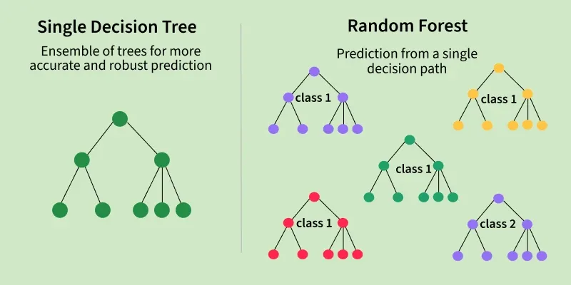
Implementing Random Forest for Regression Tasks
We will do house price prediction here.
- Load the California housing dataset and create a DataFrame with features and target.
- Separate the features and the target variable.
- Split the data into training and testing sets (80% train, 20% test).
- Initialize and train a Random Forest Regressor using the training data.
- Predict house values on test data and evaluate using MSE and R² score.
- Print a sample prediction and compare it with the actual value.
Random Forest for Regression Tasks
Advantages of Random Forest
- Random Forest provides very accurate predictions even with large datasets.
- Random Forest can handle missing data well without compromising with accuracy.
- It doesn’t require normalization or standardization on dataset.
- When we combine multiple decision trees it reduces the risk of overfitting of the model.
Limitations of Random Forest
- It can be computationally expensive especially with a large number of trees.
- It’s harder to interpret the model compared to simpler models like decision trees.

Naive Bayes Classifiers:
Naive Bayes is a machine learning classification algorithm that predicts the category of a data point using probability. It assumes that all features are independent of each other. Naive Bayes performs well in many real-world applications such as spam filtering, document categorisation and sentiment analysis.
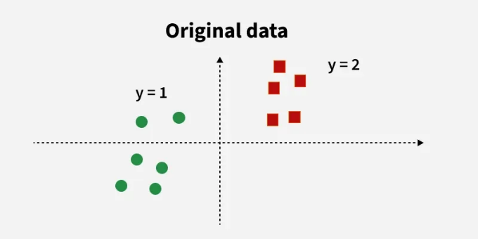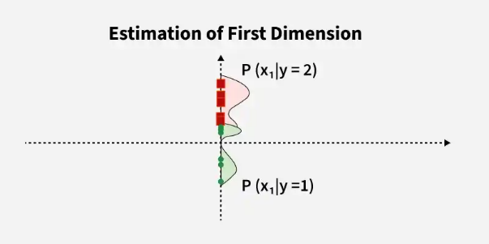

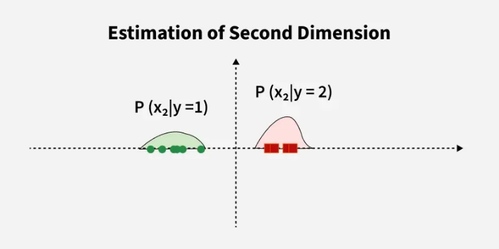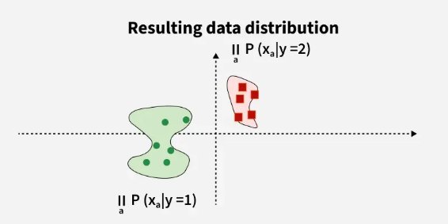
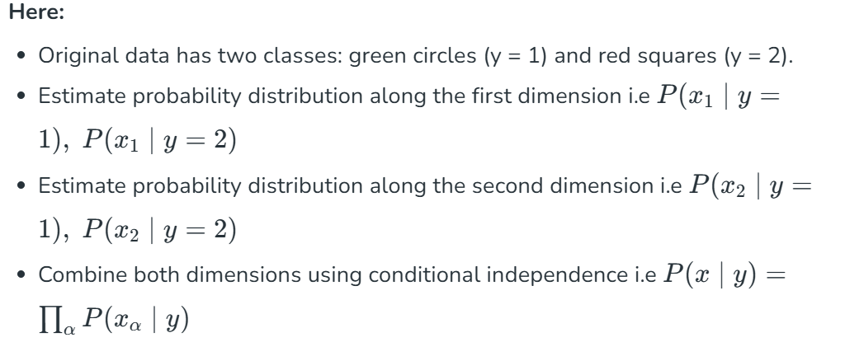 Key Features of Naive Bayes Classifiers
The main idea behind the Naive Bayes classifier is to use Bayes' Theorem to classify data based on the probabilities of different classes given the features of the data. It is used mostly in high-dimensional text classification
- The Naive Bayes Classifier is a simple probabilistic classifier and it has very few number of parameters which are used to build the ML models that can predict at a faster speed than other classification algorithms.
- It is a probabilistic classifier because it assumes that one feature in the model is independent of existence of another feature. In other words, each feature contributes to the predictions with no relation between each other.
- Naive Bayes Algorithm is used in spam filtration, Sentimental analysis, classifying articles and many more.
Why it is Called Naive Bayes?
It is named as "Naive" because it assumes the presence of one feature does not affect other features. The "Bayes" part of the name refers to its basis in Bayes’ Theorem.
Consider a fictional dataset that describes the weather conditions for playing a game of golf. Given the weather conditions, each tuple classifies the conditions as fit(“Yes”) or unfit(“No”) for playing golf. Here is a tabular representation of our dataset.
 | Outlook | Temperature | Humidity | Windy | Play Golf
0 | Rainy | Hot | High | False | Yes
1 | Rainy | Hot | High | True | No
2 | Overcast | Hot | High | False | Yes
3 | Sunny | Mild | High | False | No
4 | Sunny | Cool | Normal | False | Yes
5 | Sunny | Cool | Normal | True | No
6 | Overcast | Cool | Normal | True | Yes
7 | Rainy | Mild | High | False | No
8 | Rainy | Cool | Normal | False | Yes
9 | Sunny | Mild | Normal | False | Yes
10 | Rainy | Mild | Normal | True | Yes
11 | Overcast | Mild | High | True | Yes
12 | Overcast | Hot | Normal | False | Yes
13 | Sunny | Mild | High | True | No
The dataset is divided into two parts i.e feature matrix and the response vector.
- Feature matrix contains all the vectors(rows) of dataset in which each vector consists of the value of dependent features. In above dataset, features are ‘Outlook’, ‘Temperature’, ‘Humidity’ and ‘Windy’.
- Response vector contains the value of class variable (prediction or output) for each row of feature matrix. In above dataset, the class variable name is ‘Play golf’.
Assumption of Naive Bayes
The fundamental Naive Bayes assumption is that each feature makes an:
- Feature independence: This means that when we are trying to classify something, we assume that each feature (or piece of information) in the data does not affect any other feature.
- Continuous features are normally distributed: If a feature is continuous, then it is assumed to be normally distributed within each class.
- Discrete features have multinomial distributions: If a feature is discrete, then it is assumed to have a multinomial distribution within each class.
- Features are equally important: All features are assumed to contribute equally to the prediction of the class label.
- No missing data: The data should not contain any missing values.
Introduction to Bayes' Theorem
Bayes’ Theorem provides a principled way to reverse conditional probabilities. It is defined as:
P(y∣X)=P(X∣y)⋅P(y)/P(X)​
Where:
- P(y∣X): Posterior probability, probability of class y given features X
- P(X∣y): Likelihood, probability of features X given class y
- P(y): Prior probability of class y
- P(X): Marginal likelihood or evidence
Naive Bayes Working
1. Terminology
Consider a classification problem (like predicting if someone plays golf based on weather). Then:
- yy is the class label (e.g. "Yes" or "No" for playing golf)
- X=(x1,x2,...,xn) is the feature vector (e.g. Outlook, Temperature, Humidity, Wind)
A sample row from the dataset:
X=(Rainy, Hot, High, False),y=No
This represents:
What is the probability that someone will not play golf given that the weather is Rainy, Hot, High humidity and No wind?
2. The Naive Assumption
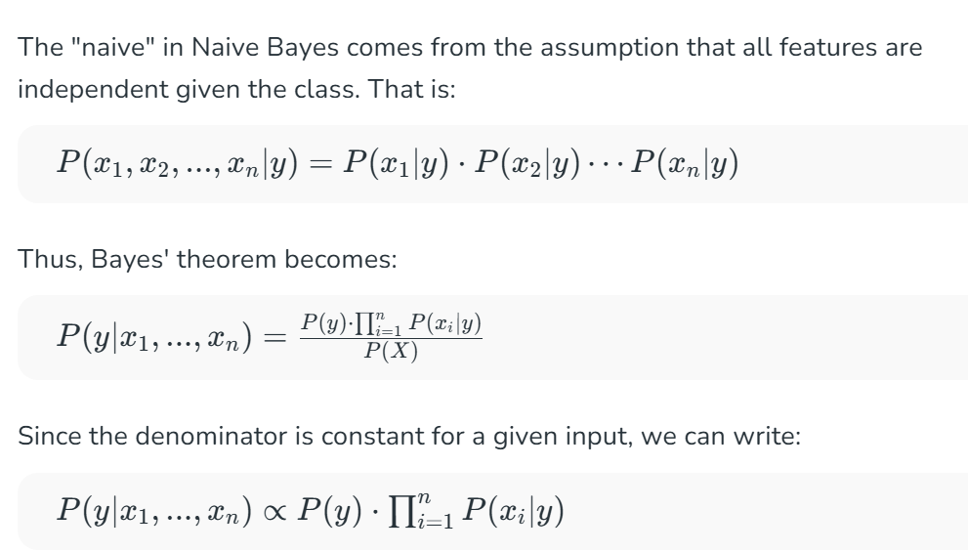
3. Constructing the Naive Bayes Classifier
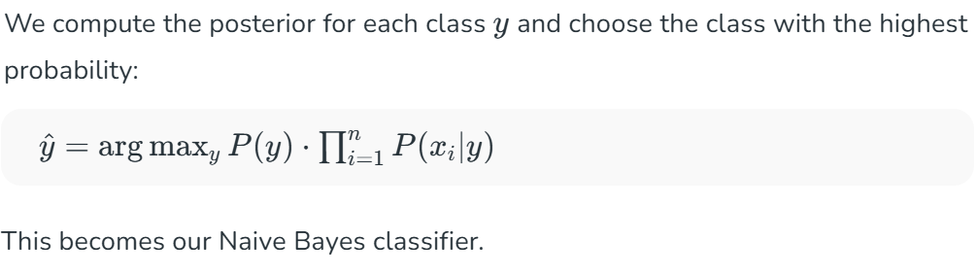 4. Example: Weather Dataset
Let’s take a dataset used for predicting if golf is played based on:
- Outlook: Sunny, Rainy, Overcast
- Temperature: Hot, Mild, Cool
- Humidity: High, Normal
- Wind: True, False
Example Input: X=(Sunny,Hot,Normal,False) X=(Sunny,Hot,Normal,False)
Goal: Predict if golf will be played (Yes or No).
5. Pre-computation from Dataset
Class Probabilities:
From dataset of 14 rows:
- P(Yes)=9/14​
- P(No)=5/14​
Conditional Probabilities (Tables 1–4):
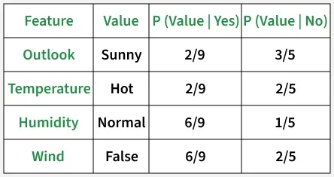
6. Calculate Posterior Probabilities
For Class = Yes:
P(Yes | today)∝2/9⋅2/9⋅6/9⋅6/9⋅9/14
P(Yes | today)≈0.02116
For Class = No:
P(No | today)∝3/5⋅2/5⋅1/5⋅2/5⋅5/14​
P(No | today)≈0.0068
7. Normalize Probabilities
To compare:
P(Yes | today)=0.021160.02116+0.0068≈0.756
P(No | today)=0.00680.02116+0.0068≈0.244
8. Final Prediction
Since:
P(Yes | today)>P(No | today)
The model predicts: Yes (Play Golf)
Naive Bayes for Continuous Features
For continuous features, we assume a Gaussian distribution:
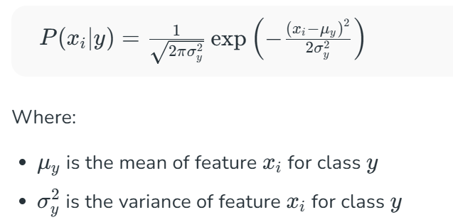 This leads to what is called Gaussian Naive Bayes.
Types of Naive Bayes Model
There are three types of Naive Bayes Model :
1. Gaussian Naive Bayes
In Gaussian Naive Bayes, continuous values associated with each feature are assumed to be distributed according to a Gaussian distribution. A Gaussian distribution is also called Normal distribution When plotted, it gives a bell shaped curve which is symmetric about the mean of the feature values as shown below:
2. Multinomial Naive Bayes
Multinomial Naive Bayes is used when features represent the frequency of terms (such as word counts) in a document. It is commonly applied in text classification, where term frequencies are important.
3. Bernoulli Naive Bayes
Bernoulli Naive Bayes deals with binary features, where each feature indicates whether a word appears or not in a document. It is suited for scenarios where the presence or absence of terms is more relevant than their frequency. Both models are widely used in document classification tasks
Advantages
- Easy to implement and computationally efficient.
- Effective in cases with a large number of features.
- Performs well even with limited training data.
- It performs well in the presence of categorical features.
- For numerical features data is assumed to come from normal distributions
Disadvantages
- Assumes that features are independent, which may not always hold in real-world data.
- Can be influenced by irrelevant attributes.
- May assign zero probability to unseen events, leading to poor generalization.
Applications
- Spam Email Filtering: Classifies emails as spam or non-spam based on features.
- Text Classification: Used in sentiment analysis, document categorization and topic classification.
- Medical Diagnosis: Helps in predicting the likelihood of a disease based on symptoms.
- Credit Scoring: Evaluates creditworthiness of individuals for loan approval.
- Weather Prediction: Classifies weather conditions based on various factors.

Write suitable example for each one which will give better score

