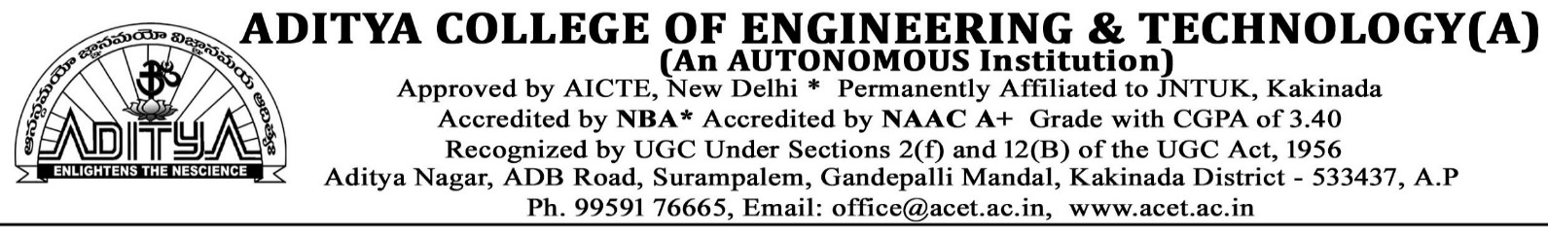
SUB: Universal human values – understanding harmony and Ethical human conduct (R23)
UNIT 1

- Explain the process of value education?
- What is value education? Why there is a need of value education?(IMP)
- What are the basic guidelines for value education? (IMP)
- What is the need for value education?
Write a short note on the need for value education in today’s seenario.
- What is the content of self – exploration? (IMP)
- Explain the process of self-exploration with a diagram? (IMP)
- What do you understand by the terms svatva, swatantrata and swarajya?
- What is happiness?
“Mutual fulfillment in human relationships is something we want, we aspire for.” Explain(IMP)
- What is the meaning of prosperity? How can you say that you are prosperous? (IMP)
- What is the need for value education in technical and other professional institutions?
- What do you understand by self exploration? Where does it take place – self or body? (IMP)
- What do you mean by your natural acceptance? Is it innate, invariant and universal? Explain
- What are the requirements to fulfill basic human aspirations? (IMP)
- What do you mean by animal and human consciousness? Explain with the help of a diagram.
- What are the basic human aspirations? Explain. (IMP)
- Differentiate between prosperity and wealth with examples.
- There are many problems manifest today at the level of individual, family, society and the nature. Identify some of these problems humans suffer from.

UNIT 2
- Distinguish between Sukh and Suvidha in detail taking needs of yourself as an example. (IMP)
- How can we ensure harmony in self (‘I’)? (IMP)
- ‘The need for physical facilities is temporary’ – explain the meaning of this statement with any two examples.
- ‘Human being is co-existence of the Self and the Body’ – elaborate on this statement. (or) (IMP)
‘Human being is the co-existence of the Self and the Body’ – Explain this statement taking yourself as an example. (IMP)
- Can the activities of the self be distinctly understood from the activites of the body? Name any three activities and elaborate.
- Discuss the problems that are created by having desire, thoughts and expectation on the basis of pre – conditioning.
- Explain with examples the various activities in the self 'I'. (IMP)
Briefly explain the activities of Desire, Thought and Expectation in the self with an example. (or)
With the help of one example each, explain how the activities of the self (selecting/ tasting, analysing, imaging) may be in harmony or disharmony?
- How does the feeling of sanyam ensure health of the body? List two programs of sanyam?
- Define Sanyam and Swasthya. How are they helpful in keeping harmony between self and body? (IMP)

UNIT 3
- Define trust. Or How is ‘trust’ the foundation value of relationships?
What do you understand by ‘trust’? What is its importance in human relationship? (IMP)
- Define ‘affection’. Or How does affection lead to harmony in the family? (IMP)
- Difference between respect and differentiation.
What is the difference between respect and disrespect? Which of the two is maturally acceptable to you?
- What is meaning of justice in human relationships? How does it follow from family to world family?(or) (IMP)
What is justice? How does it lead to mutual happiness?
- How do we come to differentiate between human beings on the basis of body? Explian. What are its consequences? (IMP)
- ‘Discrimination leads to acrimony in relationships’. Explain. What problems are created when we discriminate?
- How do you differentiate between intention and competence when you have to judge the other? Why is it important?
- List down the foundation value and the complete value in human relationship. Explain each with one example? (IMP)
- How doeas the self assume the responsibility towards the body? How does it help to ensure prosperity?
Explain the comprehensive human goal. How does fearlessness follow from right understanding and prosperity? (or) (IMP)
What do you mean by comprehensive human goal? Explain. How is it related to your goal in life? (IMP)
- There is a common saying; if you trust everybody, people will take undue advantage of you. What is the basic error in this statement? Explain.

UNIT 4
- What do you mean by ‘innateness’? What is the innateness in the four orders? (or) (IMP)
What do you understand by the term ‘innateness’ (dhaarna) in nature? Explain the innatenss of material and animal order in nature. (IMP)
- Present the difference and similarity between a human being and an animal. Give examples to support your answer?
- Explain the harmony in nature? (IMP)
- What are the four orders of nature? Briefly explain them? (IMP)
- Explain the differences and similarities between animal order and human order. What is the relation between the two orders? (IMP)

UNIT 5

- What is ethical human conduct? (OR) How does right understanding provide the basis for ethical human conduct? (IMP)
- Explain in terms of values, policies and character with appropriate examples?
- What do you understand by definitiveness of ethical human conduct? Why is this definitiveness desirable?
- How do the current world views lead to contradictions and dilemmas in professional life? – Explain? (IMP)
- What is a holistic technology? Take any two such examples from the Indian tradition and elaborate on them? (IMP)
- Give a critical review of the current management models in profession?
- What do you mean by professional ethics? (IMP)
- What do you understand by competence in professional ethics? Give two examples of its implications in industry?
- What are the implications of value based living at all four levels of living? Explain? (IMP)

*************

