IIIYearI Semester | ARTIFICIAL INTELLIGENCE | L | T | P | C
IIIYearI Semester | ARTIFICIAL INTELLIGENCE | 3 | 0 | 0 | 3

Pre-requisite:
  - KnowledgeinComputer Programming.
  - Acourseon“MathematicalFoundationsofComputer Science”.
  - Backgroundinlinearalgebra,datastructuresand algorithms,andprobability.

Course Objectives:
- The student should be made to studytheconceptsofArtificialIntelligence.
- ThestudentshouldbemadetolearnthemethodsofsolvingproblemsusingArtificial Intelligence.
- Thestudentshould bemadeto introducethe conceptsofExpert Systems.
- TounderstandtheapplicationsofAI,namelygameplaying,theoremproving,and machine learning.
- Tolearndifferentknowledgerepresentationtechniques

UNIT-I
Introduction: AIproblems, foundationofAIand historyofAIintelligent agents:Agents and Environments, the concept of rationality, the nature of environments, structure of agents, problem solving agents, problem formulation.

UNIT-II
Searching- Searching for solutions, uniformed search strategies – Breadth first search, depth first Search. Search with partial information (Heuristic search) Hill climbing, A* ,AO* Algorithms, Problem reduction, Game Playing-Adversial search, Games, mini-maxalgorithm, optimal decisions in multiplayer games, Problem in Game playing, Alpha-Beta pruning, Evaluation functions.

UNIT-III
Representation of Knowledge: Knowledge representation issues, predicate logic- logic programming, semantic nets- frames and inheritance, constraint propagation, representing knowledge using rules, rules based deduction systems. Reasoning under uncertainty, review of probability, Bayes’ probabilistic interferences and dempstershafer theory.

UNIT-IV
Logic concepts: First order logic. Inference in first order logic, propositional vs. first order inference, unification & lifts forward chaining, Backward chaining, Resolution, Learning from observation Inductive learning, Decision trees, Explanation based learning, Statistical Learning methods, Reinforcement Learning.

UNIT-V
Expert Systems: Architecture of expert systems, Roles of expert systems – Knowledge Acquisition Meta knowledge Heuristics. Typical expert systems – MYCIN, DART, XCON: Expert systems shells.

Textbooks:
- S.RusselandP.Norvig,“ArtificialIntelligence–AModernApproach”,
SecondEdition,PearsonEducation.

- KevinNightandElaineRich,NairB.,“ArtificialIntelligence(SIE)”,McGrawHill

ReferenceBooks:
- David Poole, Alan Mackworth, Randy Goebel,”Computational Intelligence: a logical approach”, Oxford University Press.
- G. Luger, “Artificial Intelligence: Structures and Strategies for complex problemsolving”, Fourth Edition, Pearson Education.
- J.Nilsson,“Artificial Intelligence:AnewSynthesis”,Elsevier Publishers.
- ArtificialIntelligence,SarojKaushik,CENGAGELearning.

OnlineLearning Resources:
- https://ai.google/
- https://swayam.gov.in/nd1_noc19_me71/preview

UNIT-I
Introduction: AI problems, foundation of AI and history of AI intelligent agents: Agents and Environments, the concept of rationality, the nature of environments, structure of agents, problem solving agents, problem formulation.

Introduction:

- Artificial Intelligence is concerned with the design of intelligence in an artificial device. The term was coined by John McCarthy in 1956.
- Intelligence is the ability to acquire, understand and apply the knowledge to achieve goals in the world.
- AI is the study of the mental faculties through the use of computational models
- AIisthestudyofintellectual/mentalprocessesascomputationalprocesses.
- AI program will demonstrate a high level of intelligence to a degree that equals or exceeds the intelligence required of a human in performing some task.
- AI is unique, sharing borders with Mathematics, Computer Science, Philosophy, Psychology, Biology, Cognitive Science and many others.
- Although there is no clear definition of AI or even Intelligence, it can be described as an attempt to build machines that like humans can think and act, able to learn and use knowledge to solve problems on their own.
Why Artificial Intelligence?

Before Learning about Artificial Intelligence, we should know that what is the importance of AI and why should we learn it. Following are some main reasons to learn about AI:
- With the help of AI, you can create such software or devices which can solve real-world problems very easily and with accuracy such as health issues, marketing, traffic issues, etc.
- With the help of AI, you can create your personal virtual Assistant, such as Cortana, Google Assistant, Siri, etc.
- With the help of AI, you can build such Robots which can work in an environment where survival of humans can be at risk.
- AI opens a path for other new technologies, new devices, and new Opportunities.
Goals of Artificial Intelligence:

Following are them a in goals of Artificial Intelligence:

- Replicate human intelligence
- Solve Knowledge-intensive tasks
- An intelligent connection of perception and action
- Building a machine which can perform tasks that requires human intelligence such as:
  - Proving a theorem
  - Playing chess
  - Plan some surgical operation
  - Driving a car in traffic
- Creating some system which can exhibit intelligent behavior, learn new things by itself, demonstrate, explain, and can advise to its user.
What Comprises to Artificial Intelligence?

Artificial Intelligence is not just a part of computer science even it's so vastand requires lots of other factors which can contribute to it. To create the AI first we should know that how intelligence is composed, so the Intelligence is an intangible part of our brain which is a combination of Reasoning,learning, problem-solving perception, language understanding, etc.
To achieve the above factors for a machine or software Artificial Intelligence requires the following discipline:
  - Mathematics
  - Biology
  - Psychology
  - Sociology
  - Computer Science
  - Neurons Study
  - Statistics

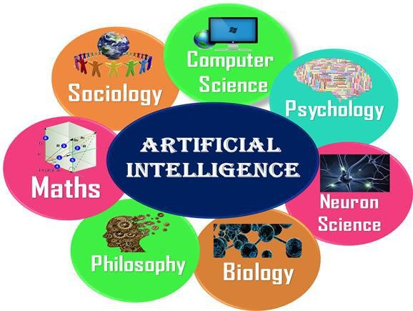

Advantages of Artificial Intelligence:

Following are some main advantages of Artificial Intelligence:

  - High Accuracy with less errors: AI machines or systems are prone to less errors and high accuracy as it takes decisions as per pre-experience or information.
  - High-Speed: AI systems can be of very high-speed and fast-decision making, because of that AI systems can beat a chess champion in the Chess game.
  - High reliability: AI machines are highly reliable and can perform the same action multiple times with high accuracy.
  - Useful for risky areas: AI machines can be helpful in situations such as defusing a bomb, exploring the ocean floor, where to employ a human can be risky.
  - Digital Assistant: AI can be very useful to provide digital assistant to the users such as AI technology is currently used by various E- commerce websites to show the products as per customer requirement.
  - Useful as a public utility: AI can be very useful for public utilities such as a self-driving car which can make our journey safer and hassle-free, facial recognition for security purpose, Natural language processing to communicate with the human in human-language, etc.
Disadvantages of Artificial Intelligence:

Every technology has some disadvantages, and the same goes for Artificial intelligence. Being so advantageous technology still, it has some disadvantages which we need to keep in our mind while creating an AI system. Following are the disadvantages of AI:
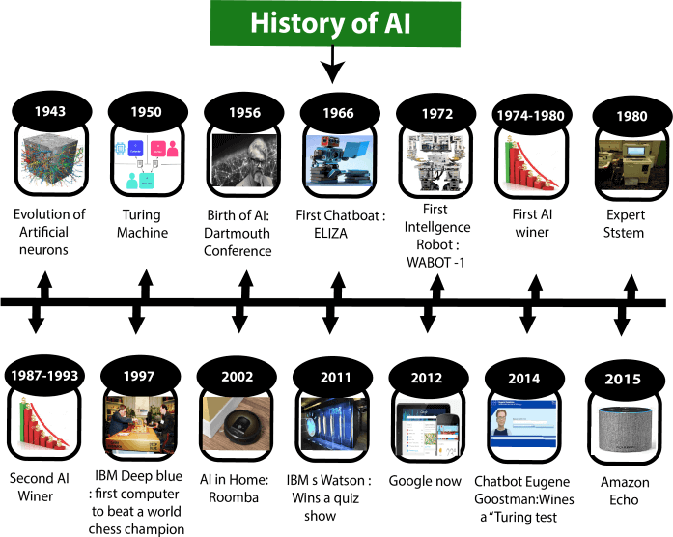
  - High Cost: The hardware and software requirement of AI is very costly as it requires lots of maintenance to meet current world requirements.
  - Can't think out of the box: Even we are making smarter machines with AI, but still they cannot work out of the box, as the robot will only do that work for which they are trained, or programmed.
  - No feelings and emotions: AI machines can be an outstanding performer, but still it does not have the feeling so it cannot make any kind of emotional attachment with human, and may sometime be harmful for users if the proper care is not taken.
  - Increase dependency on machines: With the increment of technology, people are getting more dependent on devices and hence they are losing their mental capabilities.
  - No Original Creativity: As humans are so creative and can imagine some new ideas but still AI machines cannot beat this power of human intelligence and cannot be creative and imaginative

Topic: History of Artificial Intelligence:
Artificial Intelligence is not a new word and not a new technology for researchers. This technology is much older than you would imagine.

Maturation of Artificial Intelligence (1943-1952)

  - Year 1943: The first work which is now recognized as AI was done by WarrenMcCullochandWalterpitsin1943.Theyproposedamodel of artificial neurons.
  - Year 1949: Donald Hebb demonstrated an updating rule for modifying the connection strength between neurons. His rule is now called Hebbian learning.
  - Year 1950:The Alan Turing who was an English mathematician and pioneered Machine learning in 1950. Alan Turing publishes "Computing Machinery and Intelligence" in which he proposed a test. The test can check the machine's ability to exhibit intelligent behavior equivalent to human intelligence, called a Turing test.
The birth of Artificial Intelligence(1952-1956)

  - Year 1955: An Allen Newell and Herbert A. Simon created the "first artificial intelligence program "Which was named as "Logic Theorist". This program had proved 38of 52 Mathematics theorems, and find new and more elegant proofs for some theorems.
  - Year 1956: The word "Artificial Intelligence" first adopted by American Computer scientist John McCarthy at the Dartmouth Conference. For the first time, AI coined as an academic field.
At that time high-level computer languages such as FORTRAN, LISP, or COBOL were invented. And the enthusiasm for AI was very high at that time.
The golden years-Early enthusiasm(1956-1974)

  - Year 1966: The researchers emphasized developing algorithms which can solve mathematical problems. Joseph Weizenbaum created the first chat bot in 1966, which was named as ELIZA.
  - Year 1972: The first intelligent humanoid robot was built in Japan which was named as WABOT-1.
The first AI winter (1974-1980)

  - The duration between years 1974 to 1980 was the first AI winter duration. AI winter refers to the time period where computer scientist dealt with a severe shortage of funding from government for AI researches.
  - During AI winters, an interest of publicity on artificial intelligence was decreased.
Aboom of AI(1980-1987)

  - Year 1980: After AI winter duration, AI came back with "Expert System". Expert systems were programmed that emulate the decision-making ability of a human expert.
  - In the Year 1980, the first national conference of the American Association of Artificial Intelligence was held at Stanford University.
The second AI winter (1987-1993)

  - The duration between the years 1987 to 1993 was the second AI Winter duration.
  - Again Investors and government stopped in funding for AI research as due to high cost but not efficient result. The expert system such as XCON was very cost effective.
The emergence of intelligent agents (1993-2011)

  - Year 1997: In the year 1997, IBM Deep Blue beats world chess champion, Gary Kasparov, and became the first computer to beat a world chess champion.
  - Year 2002: for the first time, AI entered the home in the form of Roomba, a vacuum cleaner.
  - Year 2006: AI came in the Business world till the year 2006. Companies like Facebook, Twitter, and Netflix also started using AI.
Deeplearning, bigdata and artificial general intelligence (2011-present)

  - Year 2011: In the year 2011, IBM's Watson won jeopardy, a quiz show, where it had to solve the complex questions as well as riddles. Watson had proved that it could understand natural language and can solve tricky questions quickly.
  - Year 2012: Google has launched an Android app feature "Google now", which was able to provide information to the user as a prediction.
  - Year 2014:In the year 2014, Chatbot "Eugene Goostman" won a competition in the infamous "Turing test."

  - Year 2018: The "Project Debater" from IBM debated on complex topics with two master debaters and also performed extremely well.
  - Google has demonstrated an AI program "Duplex" which was a virtual assistant and which had taken hairdresser appointment on call, and lady on other side didn't notice that she was talking with the machine.

Topic: Intelligent system:
Intelligent systems can also include sophisticated AI-based software systems, such as chatbots, expert systems and other types of software.
Essentially, an intelligent device is anything that contains a functional, although not usually general-purpose, computer with Internet connectivity. An embedded system may be powerful and capable of complex processing and data analysis, but it is usually specialized for tasks relevant to the host machine.
Intelligent systems exist all around us in point-of-sale (POS) terminals, digital televisions, traffic lights, smart meters, automobiles, digital signage and airplane controls, among a great number of other possibilities. Built-in intelligence is an integral component of the developing internet of things (IoT), in which almost everything imaginable can be provided with unique identifiers and the ability to automatically transfer data over a network without requiring human-to-human or human-to-computer interaction.

Topic: Foundations of AI

AI into five distinct research areas

- Machine Learning

- Expert Systems

- Computer Vision

- Natural Language Processing

- Robotics

Machine Learning:

Machine learning (ML)is the science of empowering machines to make decisions without human intervention. This sub-discipline forms the backbone of AI, enabling computers to learn and interpret patterns in images, sounds, and structured data using multidimensional arrays. ML is further subdivided into four types of learning:

  - Supervised learning: Given an array of features (i.e., week of the year, price, etc.) and a labeled output variable(e.g., sales),predict the best possible estimate of the label variable given some new input array.
  - Unsupervised learning: Given an array of features (e.g., demographic information, ZIP code, etc.), expose and visualize hidden relationships and anomalies within the array.
  - Semi-supervised: Given an array of features and a limited quantity of some labeled output variable, predict the best possible estimates for the missing label variables.
  - Reinforcement learning: Given some objective, train an artificial agent to maximize its utility according to some user-defined utility function.
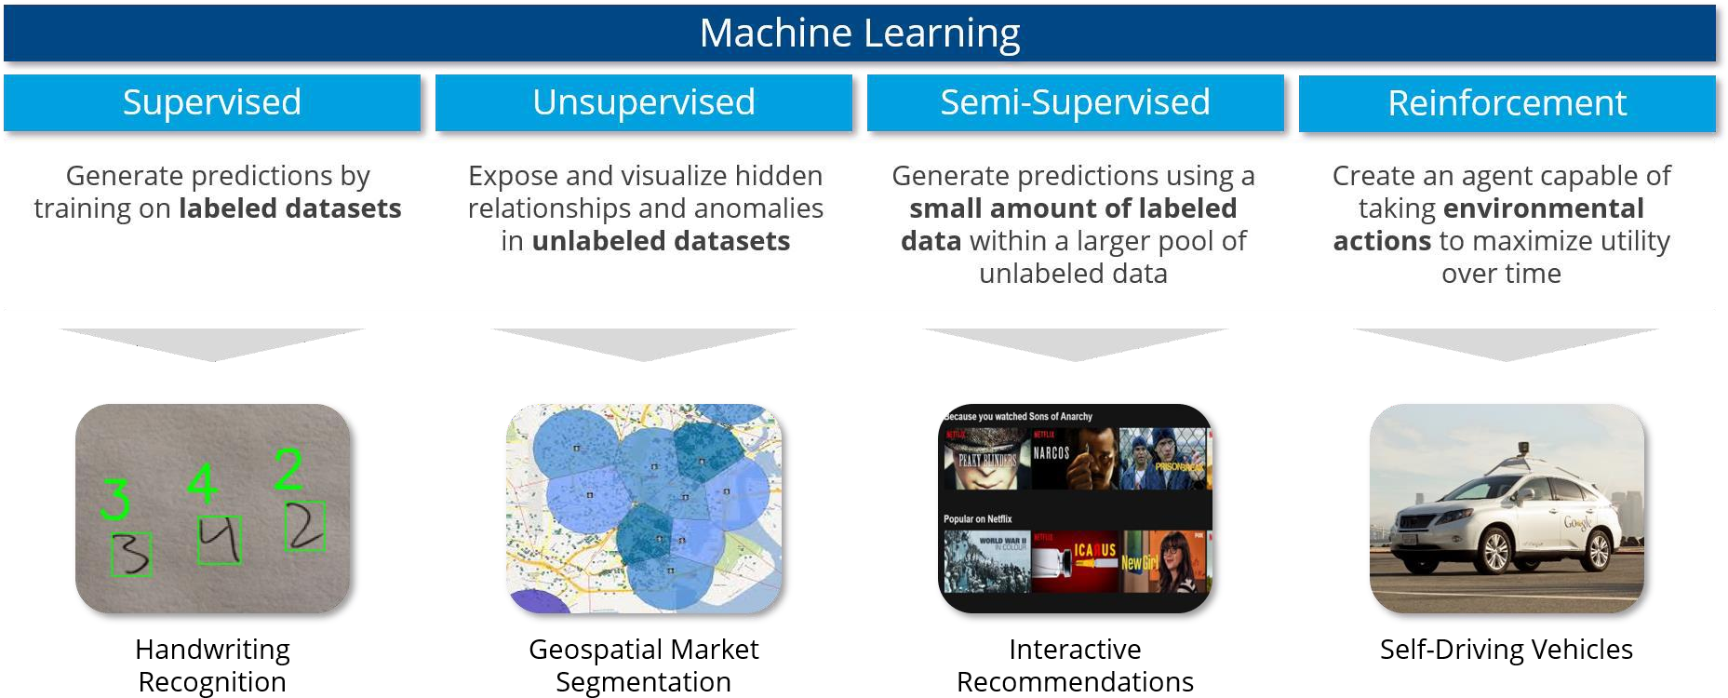

Machine learning is to thank for many high-profile innovations over the past few years, but it’s more difficult to do correctly than commonly believed.

- Expert Systems:

An expert system (ES) is an artificial agent which leverages pre-programmed knowledge to offer advice or make decisions. An expert system can take advantage of human insights discovered through trial and error
  - Expert systems are more predictable and are less likely to make extreme errors when faced with previously-unseen inputs
  - Expertsystemshavehistoricallybeenfasterandeasiertoimplement,though ML has become much more accessible in recent years
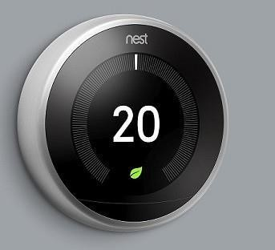
Google’s Nest thermometer
Google’s Nest home automation technology is a prime example of an ES at work. Users program their preferences into Nest over time, enabling the system to automatically adjust housing temperature to desired levels and reduce heating expenses. Using ML to predict desired temperatures could lead to wild swings in settings and energy costs, so user-defined logic is critical to stabilizing these predictions.(Another examples :MYCIN,DENDRAL,PXDES,CADET)

Computer Vision:

Computer vision (CV) is the automatic extraction, analysis, and interpretation of images or videos. CV converts photos and videos into numerical arrays, enabling ML algorithms to draw inferences, make predictions, and even generate new images based on user-defined inputs.
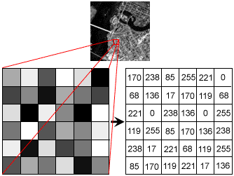
Example of an image being converted to an array:

Potential uses for CV have been studied for decades, but CV has only recently become possible at scale thanks to three innovations:

  - More efficient algorithms: Deep learning and convolutional neural networks. Specifically significantly reduces the memory footprint and computational runtime of CV tasks.
  - Better computing resources: GPU improvements, distributed architectures (e.g., Spark), and the availability of inexpensive cloud computing resources have made it cheaper than ever to run memory-hungry CV algorithms.
  - Availability of images to train on: The prolife ration of social media platforms, community forums, and digital / mobile cameras have drastically increased the number of publicly-available images that can be used to train CV algorithms.
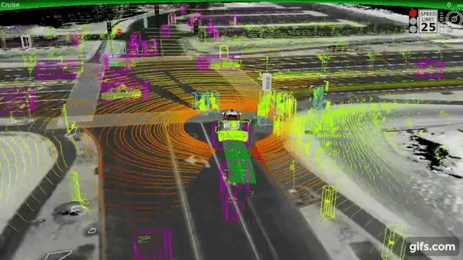

These three innovations have opened the floodgates for new CV use cases, including self-driving cars and automated retailers (e.g., Amazon Go). As cameras, LIDAR(light detection and ranging), and other spatial sensors become less expensive ,we’ll soon find ways to alleviate many of our most inefficient processes using CV.

Natural Language Processing:

Natural language processing (NLP) is the automatic extraction, analysis, and generation of human language. NLP algorithms parse sentences in various ways (e.g., splitting by word, splitting by letter, reading both left-to-right and right-to-left, etc.)toautomaticallydrawinferencesaboutthewriter’smeaningandintent.NLP’s various use cases include:
  - Name identity recognition and conference resolution

  - Part-of-speech tagging

  - Reading comprehension & question answering

  - Machine translation

  - Text summarization & topic modeling

  - Spell check &auto complete

Like CV, NLP has come a long way over the past decade thanks to innovations in deep learning that have made it faster and easier to train ML models on human language. In the past, engineers would spend hours examining, filtering, and transforming text to avoid computational bottlenecks. Today, out-of-the-box solutions like fast.ai’s NLP librarycan crush reading comprehension accuracy records without need for time-intensive preprocessing.


Siri and Alexa are great examples of NLP in action: by listening for “wake words”, these tools allow you to play music, search the Web, create to-do lists, and control popular smart-home products — all while your smart phone stays in your pocket. These virtual assistants will continue to improve overtime as they gather data from existing users, unlocking new use cases and integrating with the modern enterprise.

Robotics:
Robotics is the science of designing, constructing, operating, and applying robots to solve human problems. Robots come in thousands of shapes and sizes, making it difficult to nail down the precise meaning of the term.
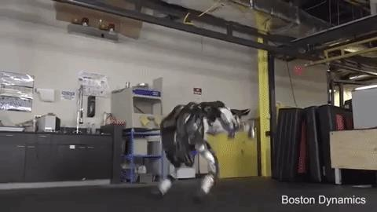
Boston Dynamic’s Atlas

The field of robotics research has evolved at breakneck speed over the past decade. Most robots rely on expert systems to accomplish their objective, but the robots of tomorrow will become exponentially more useful by incorporating machine learning, computer vision, and natural language processing into their operating systems.

Topic: AI Applications:
- AIinE-Commerce:
  - Personalized Shopping
Artificial Intelligence technology is used to create recommendation engines through which you can engage better with your customers. These recommendations are made in accordance with their browsing history, preference, and interests. It helps in improving your relationship with your customers and their loyalty towards your brand.

  - AI-powered Assistants

Virtual shopping assistants and chat bots help improve the user experience while shopping online. Natural Language Processing is used to make the conversation sound as human and personal as possible. Moreover, these assistants can have real- time engagement with your customers. Did you know that on amazon.com, soon, customer service could be handled by chat bots?
  - Fraud Prevention
Credit card frauds and fake reviews are two of the most significant issues that E- Commerce companies deal with. By considering the usage patterns, AI can help reduce the possibility of credit card frauds taking place. Many customers prefer to buy a product or service based on customer reviews. AI can help identify and handle fake reviews.
- AIin Navigation:
Based on research from MIT, GPS technology can provide users with accurate, timely, and detailed information to improve safety. The technology uses a combination of Convolutional Neural Network and Graph Neural Network, which makes lives easier for users by automatically detecting the number of lanes and road types behind obstructions on the roads. AI is heavily used by Uber and many logistics companies to improve operational efficiency, analyze road traffic, and optimize routes.
- AIin Robotics:

Robotics is another field where artificial intelligence applications are commonly used.RobotspoweredbyAIusereal-timeupdatestosenseobstaclesinitspathand pre-plan its journey instantly.

It can be used for -
- Carrying goods in hospitals, factories, and warehouses
- Cleaning offices and large equipment
- Inventory management

- AIin Human Resource
Did you know that companies use intelligent software to ease the hiring process?
Artificial Intelligence helps with blind hiring. Using machine learning software, you can examine applications based on specific parameters. AI drive systems can scan job candidates' profiles, and resumes to provide recruiters an understanding of the talent pool they must choose from.
- AIin Healthcare:
Artificial Intelligence finds diverse applications in the healthcare sector. AI is used in healthcare to build sophisticated machines that can detect diseases and identify cancer cells. AI can help analyze chronic conditions with lab and other medical data to ensure early diagnosis. AI uses the combination of historical data and medical intelligence for the discovery of new drugs.
- AIin Agriculture:
Artificial Intelligence is used to identify defects and nutrient deficiencies in the soil. This is done using computer vision, robotics, and machine learning, AI can analyze where weeds are growing. AI bots can help to harvest crops at a higher volume and faster pace than human laborers.
- AIin Gaming:
Another sector where Artificial Intelligence applications have found prominence is the gaming sector. AI can be used to create smart, human-like NPCs to interact with the players.
It can also be used to predict human behavior using which game design and testing can be improved. The Alien Isolation games released in 2014 uses AI to stalk the player throughout the game. The game uses two Artificial Intelligence systems - ‘Director AI’ that frequently knows your location and the ‘Alien AI,’ driven by sensors and behaviors that continuously hunt the player.
- AIin Auto mobiles:
Artificial Intelligence is used to build self-driving vehicles. AI can be used along with the vehicle’s camera, radar, cloud services, GPS, and control signals tooperate the vehicle. AI can improve the in-vehicle experience and provide additional systems like emergency braking, blind-spot monitoring, and driver- assist steering.
- AIin Social Media:
Instagram
On Instagram, AI considers your likes and the accounts you follow to determine what posts you are shown on your explore tab.

Facebook
Artificial Intelligence is also used along with a tool called DeepText. With this tool, Facebook can understand conversations better. It can be used to translateposts from different languages automatically.

Twitter
AI is used by Twitter for fraud detection, removing propaganda, and hateful content. Twitter also uses AI to recommend tweets that users might enjoy, basedon what type of tweets they engage with.

- AIin Marketing:
Artificial intelligence applications are popular in the marketing domain as well.
- Using AI, marketers can deliver highly targeted and personalized ads with the help of behavioral analysis, pattern recognition, etc. It also helps with retargeting audiences at the right time to ensure better results and reduced feelings of distrust and annoyance.
- AI can help with content marketing in a way that matches the brand's style and voice. It can be used to handle routine tasks like performance, campaign reports, and much more.
- Chat bots powered by AI, Natural Language Processing, Natural Language Generation, and Natural Language Understanding can analyze the user's language and respond in the ways humans do.
- AI can provide users with real-time personalization s based on their behavior and can be used to edit and optimize marketing campaigns to fit a local market's needs.

Topic: Agent
For instance, an AI agent on an online shopping platform can recommend products, answer customer questions, and process orders. If agent needs more information, it can ask users for additional details.
AI agents employ advanced natural language processing and machine learning techniques to understand user input, interact step-by-step, and use external tools when needed for accurate responses.
Common AI Agent Applications are software development and IT automation, coding tools, chat assistants, and online shopping platforms.
Agent:
An Agent is anything that can be viewed as perceiving its environment through sensors and acting upon that environment through actuators.
      - A human agent has eyes, ears, and other organs for sensors and hands, legs, mouth, and other body parts for actuators.
      - Aroboticagentmighthavecamerasandinfraredrangefindersforsensorsandvarious motors for actuators.
      - Asoftwareagentreceiveskeystrokes,filecontents,andnetworkpacketsassensory
inputs and acts on the environment by displaying on the screen, writing files, and sending network packets.

Percept:
Weusethetermpercepttorefertotheagent'sperceptualinputsatanygiveninstant.

Percept Sequence:
Anagent'sperceptsequenceisthecompletehistoryofeverythingtheagenthaseverperceived.

Agent function:
Mathematically speaking, we say that an agent's behavior is described by the agent function that maps any given percept sequence to an action.
Agent program
Internally, the agent function for an artificial agent will be implemented by an agent program. It is important to keep these two ideas distinct. The agent function is an abstract mathematical description; the agent program is a concrete implementation, running on the agent architecture.
How do AI Agents Work?
AI agents follow a structured process to perceive, analyze, decide, and act within their environment. Here’s an overview of how AI agents operate:
1. Collecting Information (Perceiving the Environment)
AI agents gather information from their surroundings through various means:
Sensors: For example, a self-driving car uses cameras and radar to detect objects.
User Input: Chatbots read text or listen to voice commands.
Databases & Documents: Virtual assistants search records or knowledge bases for relevant data.
2. Processing Information & Making Decisions
After gathering data, AI agents analyze it and decide what to do next. Some agents rely on pre-set rules, while others utilize machine learning to predict the best course of action. Advanced agents may also use retrieval-augmented generation (RAG) to access external databases for more accurate responses.
3. Taking Action (Performing Tasks)
Once an agent makes a decision, it performs the required task, such as:
Answering a customer query in a chatbot.
Controlling a device, like a smart assistant turning off lights.
Running automated tasks, such as processing orders on an online store.
4. Learning & Improving Over Time
Some AI agents can learn from past experiences to improve their responses. This self-learning process, often referred to as reinforcement learning, allows agents to refine their behavior over time. For example, a recommendation system on a streaming platform learns users' preferences and suggests content accordingly.

Problem-solving agent
The problem-solving agent perfoms precisely by defining problems and its several solutions.
According to psychology, “a problem-solving refers to a state where we wish to reach to a definite goal from a present state or condition.”
According to computer science, a problem-solving is a part of artificiall intelligence which encompasses a number of techniques such as algorithms, heuristics to solve a problem.
Therefore, a problem-solving agent is a goal-driven agentand focuses on satisfying the goal.

Steps performed by Problem-solving agent
- Goal Formulation: It is the first and simplest step in problem-solving. It organizes the steps/sequence required to formulate one goal out of multiple goals as well as
Actions to achieve that goal. Goal formulation is based on the current situation and
The agent’s performance measure (discussed below).
- Problem Formulation: It is the most important step of problem-solving which decides what actions should be taken to achieve the formulated goal. There are following five components involved in problem formulation:
- Initial State: It is the starting state or initial step of the agent towards its goal.
- Actions: It is the description of the possible actions available to the agent.
- Transition Model: It describes what each action does.
- Goal Test: It determines if the given state is a goal state.
- Path cost: It assigns a numeric cost to each path that follows the goal. The problem-solving agent selects a cost function, which reflects its performance measure. Remember, an optimal solution has the lowest path cost among all the solutions.
Note: Initial state, actions, and transition model together define the state- space of the problem implicitly. State-space of a problem is a set of all states which can be reached from the initial state followed by any sequence of actions. The state-space forms a directed map or graph where nodes are the states, links between the nodes are actions, and the path is a sequence of states connected by the sequence of actions.
- Search: It identifies all the best possible sequence of actions to reach the goal state from the current state. It takes a problem as an input and returns solution as its output.
- Solution: It finds the best algorithm out of various algorithms, which may be proven as the best optimal solution.
- Execution: It executes the best optimal solution from the searching algorithms to reach the goal state from the current state.

Example Problems

Basically , there are two types of problem approaches:
- Toy Problem: It is a concise and exact description of the problem which is used by the researchers to compare the performance of algorithms.
- Real-world Problem: It is real-world based problems which require solutions. Unlike a toy problem, it does not depend on descriptions, but we can have a general formulation of the problem.

Some Toy Problems
- 8 Puzzle Problem: Here, we havea3×3matrix with movable tiles numbered from 1 to 8 with a blank space. The tile adjacent to the blank space can slide into that space. The objective is to reach a specified goal state similar to the goal state, as shown in the below figure.
- In the figure, our task is to convert the current state into goal state by sliding digits into the blank space.
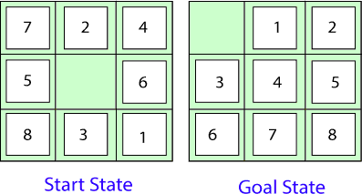
In the above figure, our task is to convert the current(Start) state into goal state by sliding digits into the blank space.

Topic :The problem formulation
- States: It describes the location of each numbered tiles and the blank tile.
- Initial State: We can start from any state as the initial state.
- Actions :Here, actions of the blank space is defined, i.e., either left, right, up or down
- Transition Model: It returns the resulting state as per the given state and actions.
- Goal test: It identifies whether we have reached the correct goal-state.
- Path cost: The path cost is the number of steps in the path where the cost of each step is 1.
Note: The 8-puzzle problem is a type of sliding-block problem which is used for testing new search algorithms in artificial intelligence.
- 8-queens problem: The aim of this problem is to place eight queens on a chessboard in an order where no queen may attack another. A queen can attack other queens either diagonally or in same row and column.
From the following figure, we can understand the problem as well as its correct solution.
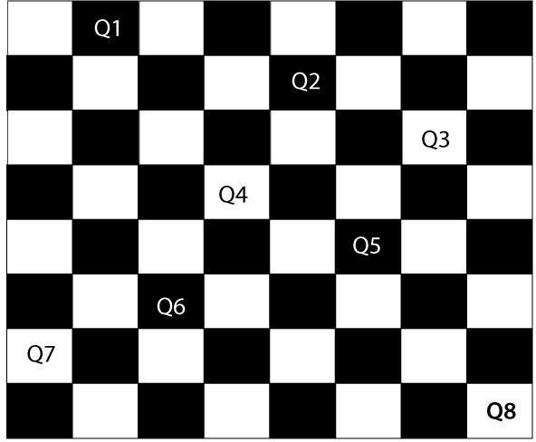
It is noticed from the above figure that each queen is set into the chessboard in a position where no other queen is placed diagonally, in same row or column. Therefore, it is one right approach to the 8-queens problem.

For this problem, the reare two main kinds of formulation:
- Incremental formulation: It starts from an empty state where the operator augments a queen at each step.

Following steps are involved in this formulation:
- States: Arrangement of any 0 to 8 queens on the chessboard.
- Initial State : An empty chessboard
- Actions: Add a queen to any empty box.
- Transition model : Returns the chessboard with the queen added in a box.
- Goal test: Checks whether8-queensareplacedonthechessboardwithoutany attack.
- Path cost: There is no need for path cost because only final states are counted.
In this formulation, there is approximately 1.8x10¹⁴possiblesequenceto investigate.
- Complete-state formulation: It starts with all the 8-queens on the chessboard and moves them around, saving from the attacks.

Following steps are involved in this formulation
- States: Arrangement of all the 8 queens one per column with no queen attacking the other queen.
- Actions: Move the queen at the location where it is safe from the attacks.
This formulation is better than the incremental formulation as it reduces the state space from 1.8 x 10¹⁴to 2057, and it is easy to find the solutions.

Some Real-world problems
- Traveling salesperson problem(TSP):It is a touring problem where the salesman can visit each city only once. The objective is to find the shortest tour and sell-out the stuff in each city.
- VLSI Layout problem: In this problem, millions of components and connections are positioned on a chip in order to minimize the area, circuit-delays, stray- capacitances, and maximizing the manufacturing yield.

The lay out problem is split into two parts:
- Cell layout: Here, the primitive components of the circuit are grouped into cells, each performing its specific function. Each cell has a fixed shape and size. The task is to place the cells on the chip without overlapping each other.
- Channel routing: It finds a specific route for each wire through the gaps between the cells.
- Protein Design: The objective is to find a sequence of amino acids which will fold into 3D protein having a property to cure some disease.

Searching for solutions
We have seen many problems. Now, there is a need to search for solutions to solve them.
In this section, we will understand how searching can be used by the agent to solve a problem.
For solving different kinds of problem, an agent makes use of different strategies to reach the goal by searching the best possible algorithms. This process of searching is known as search strategy.

Measuring problem-solving performance
Before discussing different search strategies, the performance measure of an algorithm should be measured. Consequently, There are four ways to measure the performance of an algorithm:
Completeness:Itmeasuresifthealgorithmguaranteestofindasolution(ifany solution exist).
Optimality: It measures if the strategy searches for an optimal solution. Time Complexity: The time taken by the algorithm to find a solution. Space Complexity: Amount of memory required to perform a search.
The complexity of an algorithm depends on branching factor or maximum number of successors, depth of the shallowest goal node(i.e., number of steps from root to the path) and the maximum length of any path in a state space.

Search Strategies
There are two types of strategies that describe a solution for a given problem:

Uninformed Search(Blind Search)
This type of search strategy does not have any additional information about the states except the information provided in the problem definition. They can only generate the successors and distinguish a goal state from a non-goal state. These type of search does not maintain any internal state, that’s why it is also known as Blind search.
An AI agent is a software program that can interact with its surroundings, gather information, and use that information to complete tasks on its own to achieve goals set by humans.
Architecture of AI Agents
The architecture of AI agents serves as the blueprint for how they function.
There are four main components in an AI agent’s architecture:
Profiling Module: This module helps the agent understand its role and purpose. It gathers information from the environment to form perceptions.
Example: A self-driving car uses sensors and cameras to detect obstacles.
Memory Module: The memory module enables the agent to store and retrieve past experiences. This helps the agent learn from prior actions and improve over time.
Example: A chatbot remembers past conversations to give better responses.
Planning Module: This module is responsible for decision-making. It evaluates situations, weighs alternatives, and selects the most effective course of action.
Example: A chess-playing AI plans its moves based on future possibilities.
Action Module: The action module executes the decisions made by the planning module in the real world. It translates decisions into real-world actions.
Example: A robot vacuum moves to clean a designated area after detecting dirt.
AI Agent Classification
An agent is a system designed to perceive its environment, make decisions, and take actions to achieve specific goals. Agents operate autonomously, without direct human control, and can be classified based on their behavior, environment, and number of interacting agents.
Reactive Agents respond to immediate stimuli in their environment, making decisions based on current conditions without planning ahead.
Proactive Agents take initiative, planning actions to achieve long-term goals by anticipating future conditions.
Fixed Environments have stable rules and conditions, allowing agents to act based on static knowledge.
Dynamic Environments are constantly changing, requiring agents to adapt and respond to new situations in real-time.
Single-Agent Systems involve one agent working independently to solve a problem or achieve a goal.
Multi-Agent Systems involve multiple agents that collaborate, communicate, and coordinate to achieve a shared objective.
Rational agent is one that chooses actions based on the goal of achieving the best possible outcome, considering both past and present information.
Key Components of an AI System
An AI system includes the agent, which perceives the environment through sensors and acts using actuators, and the environment, in which it operates.
AI agents are essential in fields like robotics, gaming, and intelligent systems, where they use various techniques such as machine learning to enhance decision-making and adaptability.
Interaction of Agents with Environment
Interaction of Agents with the Environment
Structure of an AI Agent
The structure of an AI agent is composed of two key components: Architecture and Agent Program. Understanding these components is essential to grasp how intelligent agents function.
1. Architecture
Architecture refers to the underlying hardware or system on which the agent operates. It is the "machinery" that enables the agent to perceive and act within its environment. Examples of architecture include devices equipped with sensors and actuators, such as a robotic car, camera, or a PC. These physical components enable the agent to gather sensory input and execute actions in the world.
2. Agent Program
Agent Program is the software component that defines the agent's behavior. It implements the agent function, which is a mapping from the agent's percept sequence (the history of all perceptions it has gathered so far) to its actions. The agent function determines how the agent will respond to different inputs it receives from its environment.
Agent = Architecture + Agent Program
The overall structure of an AI agent can be understood as a combination of both the architecture and the agent program. The architecture provides the physical infrastructure, while the agent program dictates the decision-making and actions of the agent based on its perceptual inputs.

Characteristics of an Agent
Types of Agents
1. Simple Reflex Agents
Simple reflex agents act solely based on the current percept and, percept history (record of past perceptions) is ignored by these agents. Agent function is defined by condition-action rules.
A condition-action rule maps a state (condition) to an action.
If the condition is true, the associated action is performed.
If the condition is false, no action is taken.
Simple reflex agents are effective in environments that are fully observable (where the current percept gives all needed information about the environment). In partially observable environments, simple reflex agents may encounter infinite loops because they do not consider the history of previous percepts. Infinite loops might be avoided if the agent can randomize its actions, introducing some variability in its behavior.
Simple Reflex Agents
2. Model-Based Reflex Agents
Model-based reflex agents finds a rule whose condition matches the current situation or percept. It uses a model of the world to handle situations where the environment is only partially observable.
The agent tracks its internal state, which is adjusted based on each new percept.
The internal state depends on the percept history (the history of what the agent has perceived so far).
The agent stores the current state internally, maintaining a structure that represents the parts of the world that cannot be directly seen or perceived. The process of updating the agent’s state requires information about:
How the world evolves independently from the agent?
How the agent's actions affect the world?
Model-Based Reflex Agents
3. Goal-Based Agents
Goal-based agents make decisions based on their current distance from the goal and every action the agent aims to reduce the distance from goal. They can choose from multiple possibilities, selecting the one that best leads to the goal state.

Knowledge that supports the agent's decisions is represented explicitly, meaning it's clear and structured. It can also be modified, allowing for adaptability.
The ability to modify the knowledge makes these agents more flexible in different environments or situations.
Goal-based agents typically require search and planning to determine the best course of action.
Goal-Based Agents
4. Utility-Based Agents
Utility-based agents are designed to make decisions that optimize their performance by evaluating the preferences (or utilities) for each possible state. These agents assess multiple alternatives and choose the one that maximizes their utility, which is a measure of how desirable or "happy" a state is for the agent.
Achieving the goal is not always sufficient; for example, the agent might prefer a quicker, safer, or cheaper way to reach a destination.
The utility function is essential for capturing this concept, mapping each state to a real number that reflects the agent’s happiness or satisfaction with that state.
Since the world is often uncertain, utility-based agents choose actions that maximize expected utility, ensuring they make the most favorable decision under uncertain conditions.
Utility-Based Agents
5. Learning Agent
A learning agent in AI is the type of agent that can learn from its past experiences or it has learning capabilities. It starts to act with basic knowledge and then is able to act and adapt automatically through learning. A learning agent has mainly four conceptual components, which are:

Learning element: It is responsible for making improvements by learning from the environment.
Critic: The learning element takes feedback from critics which describes how well the agent is doing with respect to a fixed performance standard.
Performance element: It is responsible for selecting external action.
Problem Generator: This component is responsible for suggesting actions that will lead to new and informative experiences.
Learning Agent
6. Multi-Agent Systems
Multi-Agent Systems (MAS) consists of multiple interacting agents working together to achieve a common goal. These agents can be autonomous or semi-autonomous, capable of perceiving their environment, making decisions, and taking action.
MAS can be classified into:
Homogeneous MAS: Agents have the same capabilities, goals, and behaviors.
Heterogeneous MAS: Agents have different capabilities, goals, and behaviors, leading to more complex but flexible systems.
Cooperative MAS: Agents work together to achieve a common goal.
Competitive MAS: Agents work against each other for their own goals.
MAS can be implemented using game theory, machine learning, and agent-based modeling.
7. Hierarchical Agents
Hierarchical Agents are organized into a hierarchy, with high-level agents overseeing the behavior of lower-level agents. The high-level agents provide goals and constraints, while the low-level agents carry out specific tasks. They are useful in complex environments with many tasks and sub-tasks.
This structure is beneficial in complex systems with many tasks and sub-tasks, such as robotics, manufacturing, and transportation. Hierarchical agents allow for efficient decision-making and resource allocation, improving system performance. In such systems, high-level agents set goals, and low-level agents execute tasks to achieve those goals.
Uses of Agents
Agents are used in a wide range of applications in artificial intelligence, including:
Robotics: Agents can be used to control robots and automate tasks in manufacturing, transportation, and other industries.
Smart homes and buildings: Agents can be used to control heating, lighting, and other systems in smart homes and buildings, optimizing energy use and improving comfort.
Transportation systems: Agents can be used to manage traffic flow, optimize routes for autonomous vehicles, and improve logistics and supply chain management.
Healthcare: Agents can be used to monitor patients, provide personalized treatment plans, and optimize healthcare resource allocation.
Finance: Agents can be used for automated trading, fraud detection, and risk management in the financial industry.
Games: Agents can be used to create intelligent opponents in games and simulations, providing a more challenging and realistic experience for players.
Topic: What is a Rational Agent in AI?
A rational agent has a clear preference, models uncertainty, and acts in a way that maximizes its performance measure using all available actions. A rational agent is said to do the appropriate thing. AI is about developing rational agents for use in game theory and decision theory in various real-world contexts.
Rational action is crucial for an AI agent since the AI reinforcement learning algorithm rewards the best possible action with a positive reward and penalizes the worst possible action with a negative reward. A rational AI agent is a system that performs actions to obtain the best possible outcome or, in the case of uncertainty, the best-expected outcome.
Introduction to Rationality in AI
Rationality in AI refers to the ability of an artificial agent to make decisions that maximize its performance based on the information it has and the goals it seeks to achieve. In essence, a rational AI system aims to choose the best possible action from a set of alternatives to achieve a specific objective. This involves logical reasoning, learning from experiences, and adapting to new situations.
Types of Rationality
There are two primary types of rationality in AI: bounded rationality and perfect rationality.
1. Bounded Rationality
Bounded rationality recognizes that decision-making capabilities are limited by the information available, cognitive limitations, and time constraints. AI systems operating under bounded rationality use heuristics and approximations to make decisions that are good enough, rather than optimal. This approach is practical in real-world applications where perfect information and infinite computational resources are unavailable.
2. Perfect Rationality
Perfect rationality assumes that an AI system has access to complete information, unlimited computational power, and infinite time to make decisions. While this is an idealized concept, it serves as a benchmark for evaluating the performance of AI systems. Perfectly rational AI would always make the best possible decision in any given situation.
How Does a Rational Agent Work?
A rational agent is mainly used for goal-oriented agents. It evaluates its environment by examining what it is like.
It then examines each available action in its armory to see how it will alter the surroundings and assist it achieve its goal.
It tests all possible steps before selecting the best one, the one that would bring it closest to its goal.
Rational agents are also used in self-driving cars, energy-saving air-conditioning units, automated lights, and other devices that require environmental data to choose the optimal course of action.
Criteria for Measuring Rationality
Rationality is crucial for solving many problems on both a local and global scale. This is typically founded on the belief that rationality is required to act efficiently and achieve a variety of goals.
This includes goals from several domains, such as ethics, humanism, science, and religion.
The study of rationality dates back to ancient Greece and has captivated many of the finest minds.
This interest is frequently fueled by a desire to understand our minds' potential and limitations. Various theories even regard rationality as the essence of being human, frequently to distinguish humans from other species.
Achieving Rationality in AI
Implementing rationality in AI involves several techniques and approaches:
1. Decision Theory
Decision theory provides a framework for making rational choices by evaluating the potential outcomes of different actions. It combines probability theory and utility theory to calculate the expected utility of each action and select the one with the highest expected utility. This approach is widely used in AI for planning and problem-solving tasks.
2. Game Theory
Game theory studies strategic interactions between agents, where the outcome for each participant depends on the actions of others. In AI, game theory is used to model and analyze competitive and cooperative scenarios, enabling agents to make rational decisions in multi-agent environments.
3. Machine Learning
Machine learning algorithms enable AI systems to learn from data and improve their decision-making over time. By identifying patterns and relationships in data, machine learning models can make more accurate predictions and choose actions that maximize performance.
4. Logic and Reasoning
Logical reasoning involves using formal rules and knowledge representations to infer new information and make decisions. Techniques such as propositional logic, predicate logic, and Bayesian networks help AI systems reason about the world and make rational decisions based on the knowledge they possess.
5. Reinforcement Learning
Reinforcement learning is a type of machine learning where an agent learns to make decisions by interacting with an environment. The agent receives feedback in the form of rewards or penalties and uses this feedback to learn a policy that maximizes cumulative rewards. This approach is particularly effective for sequential decision-making problems.
Topic: The Nature of Environments in AI
The environment is everything external to the AI agent that affects its actions and decisions. AI agents interact with various environments, which influence their behavior.

The Nature of Environments
Some programs operate in the entirely artificial environment confined to keyboard input, database, computer file systems and character output on a screen.
In contrast, some software agents (software robots or softbots) exist in rich, unlimited softbots domains. The simulator has a very detailed, complex environment. The software agent needs to choose from a long array of actions in real time. A softbot designed to scan the online preferences of the customer and show interesting items to the customer works in the real as well as an artificial environment.
The most famous artificial environment is the Turing Test environment, in which one real and other artificial agents are tested on equal ground. This is a very challenging environment as it is highly difficult for a software agent to perform as well as a human.

Turing Test
The success of an intelligent behavior of a system can be measured with Turing Test.
Two persons and a machine to be evaluated participate in the test. Out of the two persons, one plays the role of the tester. Each of them sits in different rooms. The tester is unaware of who is machine and who is a human. He interrogates the questions by typing and sending them to both intelligences, to which he receives typed responses.
This test aims at fooling the tester. If the tester fails to determine machines response from the human response, then the machine is said to be intelligent.

Properties of Environment
The environment has multifold properties −
- Discrete / Continuous − If there are a limited number of distinct, clearly defined, states of the environment, the environment is discrete (For example, chess); otherwise it is continuous (For example, driving).
- Observable / Partially Observable − If it is possible to determine the complete state of the environment at each time point from the percepts it is observable; otherwise it is only partially observable.
- Static / Dynamic − If the environment does not change while an agent is acting, then it is static; otherwise it is dynamic.
- Single agent / Multiple agents − The environment may contain other agents which may be of the same or different kind as that of the agent.
- Accessible / Inaccessible − If the agents sensory apparatus can have access to the complete state of the environment, then the environment is accessible to that agent.
- Deterministic / Non-deterministic − If the next state of the environment is completely determined by the current state and the actions of the agent, then the environment is deterministic; otherwise it is non-deterministic.
- Episodic / Non-episodic − In an episodic environment, each episode consists of the agent perceiving and then acting. The quality of its action depends just on the episode itself. Subsequent episodes do not depend on the actions in the previous episodes. Episodic environments are much simpler because the agent does not need to think ahead.

Topic:Structure of an AI Agent
The structure of an AI agent is composed of two key components: Architecture and Agent Program. Understanding these components is essential to grasp how intelligent agents function.

1. Architecture
Architecture refers to the underlying hardware or system on which the agent operates. It is the "machinery" that enables the agent to perceive and act within its environment. Examples of architecture include devices equipped with sensors and actuators, such as a robotic car, camera, or a PC. These physical components enable the agent to gather sensory input and execute actions in the world.

2. Agent Program
Agent Program is the software component that defines the agent's behavior. It implements the agent function, which is a mapping from the agent's percept sequence (the history of all perceptions it has gathered so far) to its actions. The agent function determines how the agent will respond to different inputs it receives from its environment.
Agent = Architecture + Agent Program
The overall structure of an AI agent can be understood as a combination of both the architecture and the agent program. The architecture provides the physical infrastructure, while the agent program dictates the decision-making and actions of the agent based on its perceptual inputs.
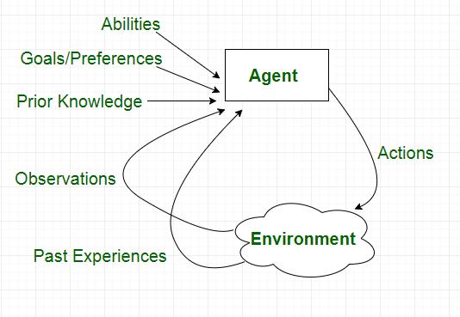
Characteristics of an Agent
Types of Agents

1. Simple Reflex Agents
Simple reflex agents act solely based on the current percept and, percept history (record of past perceptions) is ignored by these agents. Agent function is defined by condition-action rules.
A condition-action rule maps a state (condition) to an action.
- If the condition is true, the associated action is performed.
- If the condition is false, no action is taken.
Simple reflex agents are effective in environments that are fully observable (where the current percept gives all needed information about the environment). In partially observable environments, simple reflex agents may encounter infinite loops because they do not consider the history of previous percepts. Infinite loops might be avoided if the agent can randomize its actions, introducing some variability in its behavior.
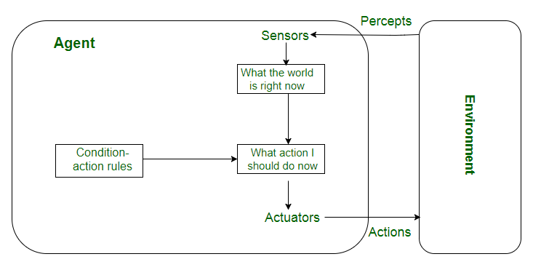
Simple Reflex Agents

2. Model-Based Reflex Agents
Model-based reflex agents finds a rule whose condition matches the current situation or percept. It uses a model of the world to handle situations where the environment is only partially observable.
- The agent tracks its internal state, which is adjusted based on each new percept.
- The internal state depends on the percept history (the history of what the agent has perceived so far).
The agent stores the current state internally, maintaining a structure that represents the parts of the world that cannot be directly seen or perceived. The process of updating the agent’s state requires information about:
- How the world evolves independently from the agent?
- How the agent's actions affect the world?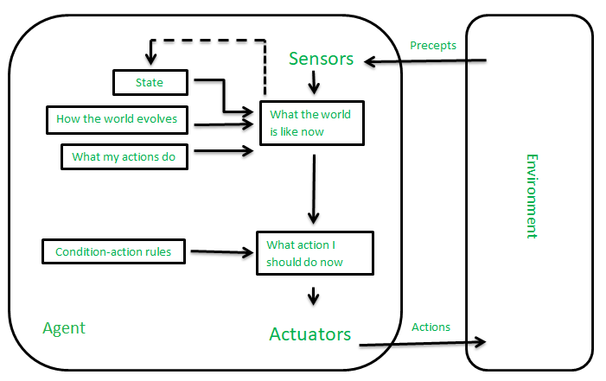Model-Based Reflex Agents

3. Goal-Based Agents
Goal-based agents make decisions based on their current distance from the goal and every action the agent aims to reduce the distance from goal. They can choose from multiple possibilities, selecting the one that best leads to the goal state.
- Knowledge that supports the agent's decisions is represented explicitly, meaning it's clear and structured. It can also be modified, allowing for adaptability.
- The ability to modify the knowledge makes these agents more flexible in different environments or situations.
Goal-based agents typically require search and planning to determine the best course of action.
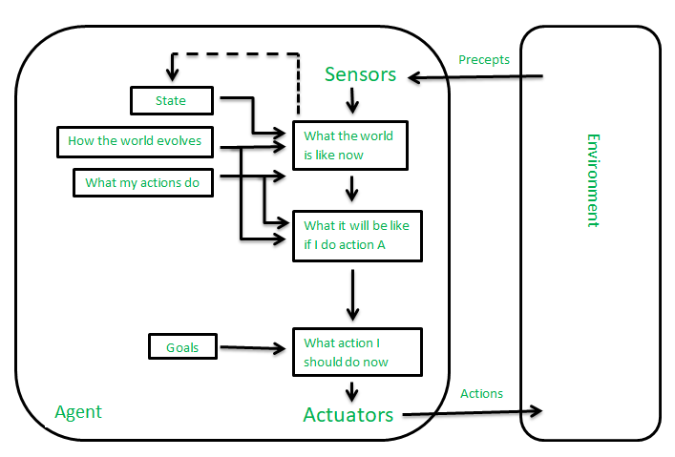
Goal-Based Agents

4. Utility-Based Agents
Utility-based agents are designed to make decisions that optimize their performance by evaluating the preferences (or utilities) for each possible state. These agents assess multiple alternatives and choose the one that maximizes their utility, which is a measure of how desirable or "happy" a state is for the agent.
- Achieving the goal is not always sufficient; for example, the agent might prefer a quicker, safer, or cheaper way to reach a destination.
- The utility function is essential for capturing this concept, mapping each state to a real number that reflects the agent’s happiness or satisfaction with that state.
Since the world is often uncertain, utility-based agents choose actions that maximize expected utility, ensuring they make the most favorable decision under uncertain conditions.
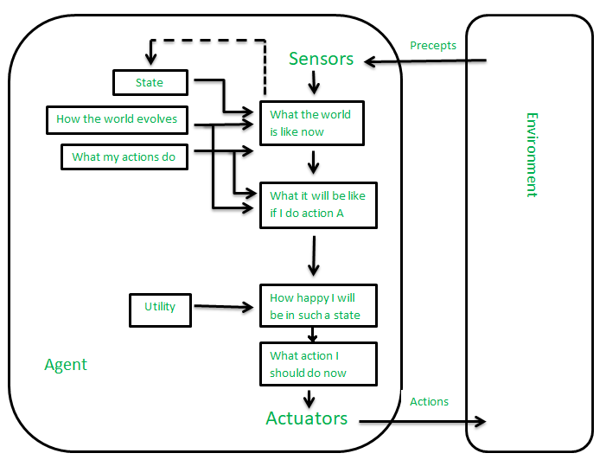
Utility-Based Agents

5. Learning Agent
A learning agent in AI is the type of agent that can learn from its past experiences or it has learning capabilities. It starts to act with basic knowledge and then is able to act and adapt automatically through learning. A learning agent has mainly four conceptual components, which are:
- Learning element: It is responsible for making improvements by learning from the environment.
- Critic: The learning element takes feedback from critics which describes how well the agent is doing with respect to a fixed performance standard.
- Performance element: It is responsible for selecting external action.
- Problem Generator: This component is responsible for suggesting actions that will lead to new and informative experiences.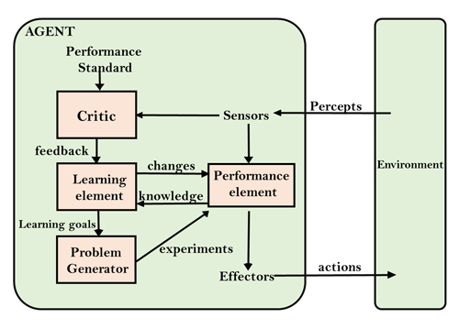Learning Agent

6. Multi-Agent Systems
Multi-Agent Systems (MAS) consists of multiple interacting agents working together to achieve a common goal. These agents can be autonomous or semi-autonomous, capable of perceiving their environment, making decisions, and taking action.
MAS can be classified into:
- Homogeneous MAS: Agents have the same capabilities, goals, and behaviors.
- Heterogeneous MAS: Agents have different capabilities, goals, and behaviors, leading to more complex but flexible systems.
- Cooperative MAS: Agents work together to achieve a common goal.
- Competitive MAS: Agents work against each other for their own goals.
MAS can be implemented using game theory, machine learning, and agent-based modeling.

7. Hierarchical Agents
Hierarchical Agents are organized into a hierarchy, with high-level agents overseeing the behavior of lower-level agents. The high-level agents provide goals and constraints, while the low-level agents carry out specific tasks. They are useful in complex environments with many tasks and sub-tasks.
This structure is beneficial in complex systems with many tasks and sub-tasks, such as robotics, manufacturing, and transportation. Hierarchical agents allow for efficient decision-making and resource allocation, improving system performance. In such systems, high-level agents set goals, and low-level agents execute tasks to achieve those goals.

