What do you mean by Typeface? Write typeface in reference with Indian scripts.

A typeface is the overall visual design of a letter collection, while a font is the specific digital file or physical style (like bold, italic, or a specific point size) used to display that design

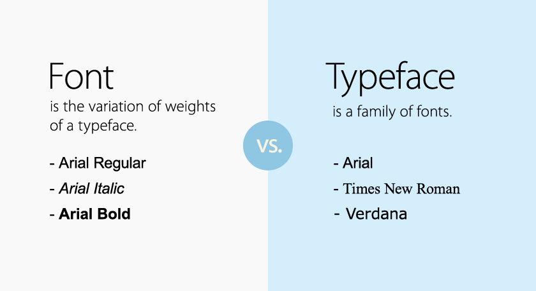
Feature | Typeface (The Design) | Font (The Implementation)
Definition | The overarching artistic style and look of the characters. | The specific weight, style, and size package you apply.
Physical/Digital Form The concept or family name. The actual .ttf or .otf computer file.
Analogy | A clothing style (e.g., Athletic Wear). | A specific piece of clothing (e.g.,  Red Medium Jacket).

Example: Arial

- Typeface: Arial (the general set of proportions and shapes).
- Fonts:
  - Arial Regular
  - Arial Italic
  - Arial Bold 18pt

Typeface design for Indian scripts involves creating complex letterforms, conjuncts, and vowel marks that respect the unique visual heritage of Indic writing systems.

Characteristics of Indian Typography

- Complex Structures: Indian scripts use stacked letters (conjuncts) and vowel signs (diacritics) placed above, below, or beside base consonants.
- Material History: Letter shapes evolved based on writing tools. For example, Kannada letters became rounded because straight lines tore palm leaves.
- The Matra: Many scripts, like Bengali and Devanagari, use a continuous horizontal top line called a matra.

History and Challenges
- Mechanical Limits: Early metal printing and typesetting machines, like Linotype, had limited keys and lacked kerning. This made proper alignment of Indian vowel marks difficult.
- Digital Gap: Early digital fonts from the 1990s were low quality and treated Indic scripts as an afterthought compared to the Latin alphabet.
- Pioneers: Designer R.K. Joshi created some of the earliest modern Indian Unicode fonts, like Mangal and Latha, released by Microsoft in 2001.

Modern Innovations

- Multi-Script Fonts: Contemporary type designers build unified families that support multiple Indic scripts alongside Latin with equal visual weight.
- Open Source Growth: Projects like Mukta and Oli Grotesk provide free, high-quality digital tools for regional languages.
- Community Exploration: Designers continue to experiment with vernacular letterforms, viewable across Indian Scripts Typeface Projects on Behance.

Key Characteristics of Indian Typefaces

- Complex Conjuncts: Letters combine into new shapes when consonants cluster together.
- Matra and Diacritics: Vowel signs sit above, below, before, or after base consonants.
- Vertical and Horizontal Flow: Scripts like Bengali use a top horizontal line (matra), while others hang from an overhead line or feature rounded loops suited for palm-leaf writing (like Kannada).

Historical Background

- Early Roots: Indian writing traces back to the Indus Valley pictographic scripts and ancient Brahmi.
- Mechanical Era Challenges: Early typewriters and metal typesetting (like Monotype and Linotype in the 20th century) struggled with the high number of glyph variations needed for Indic scripts.
- Digital Shift: Early digital fonts in the 1990s and 2000s were basic and low quality. Designers like R.K. Joshi helped create foundational fonts like Mangal for Windows.

Modern Developments

- Open Source Growth: Collectives like Ek Type created families like Mukta and Anek to support multiple Indian languages equally alongside Latin scripts.
- UI/UX Focus: Typefaces such as Hind are designed specifically for digital screens and mobile user interfaces.

