What do you mean by Ancient Indian calligraphy styles?

Calligraphy is the art of decorative, stylized, and harmonious handwriting where letterforms are drawn stroke-by-stroke rather than written quickly like regular cursive.

Comparative Overview of Major Indian Calligraphic Scripts
The history of Indian calligraphy is marked by the evolution and diversity of numerous scripts, each with its own distinct characteristics and regional influences. The following table provides a concise overview of the major Indian calligraphic scripts, comparing their time periods, regions of prominence, and key features:
Script | Time Period | Region | Characteristics
Brahmi | 3rd century BCE – 3rd century CE | Pan-India | Earliest post-Indus script, basis for many later scripts
Gupta | 4th – 6th century CE | North India | Refined, standardized form of Brahmi
Siddham | 6th – 12th century CE | East India | Used for Buddhist texts, precise and uniform strokes
Sharada | 8th – 12th century CE | Kashmir | Angular and upright strokes, used for Sanskrit texts
Devanagari | 13th century CE – present | North and Central India | Used for Sanskrit, Hindi, and other languages
Persian | 12th – 19th century CE | North India and Deccan | Introduced during Islamic rule, influenced Indo-Islamic styles

What is the Modi Script and Grantha script?
The Modi script is more than just an old writing style — it’s a vital piece of Maharashtra’s administrative, cultural, and linguistic identity. Developed around the 12th century, Modi Script was used for over 700 years as the primary script for writing Marathi, especially in royal courts and government records.
Unlike the Devanagari script we see today, Modi is a flowing, cursive script designed for speed and efficiency. It was ideal for administrative work, accounting, and correspondence — the lifeblood of the powerful Peshwa administration that ruled from Pune and nearby regions like Menavli.
During the reign of the Peshwas, led by visionary statesmen like Nana Fadnavis, Modi Script was everywhere — from royal decrees to legal documents, tax records, and daily communication. It was a script that captured the pulse of a thriving Maratha Empire.
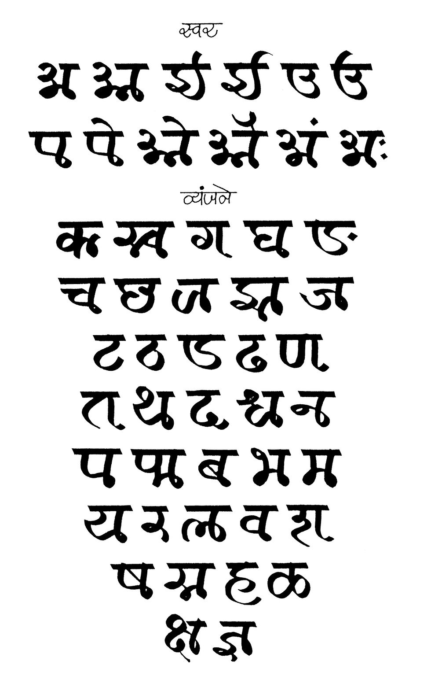

The Grantha script is a South Indian Brahmic script that evolved from the Pallava script starting around the 4th to 6th century CE.

Key Features and History

Origin of the Name: Grantha means "knot" in Sanskrit, referring to the historical practice of binding inscribed palm leaves together with a cord.

Primary Purpose: It was designed and used primarily in South India (especially Tamil Nadu and Kerala) to write and preserve sacred texts in Sanskrit, as well as the classical literary style Manipravalam.

Lineage & Descendants: It is a direct ancestor of the Malayalam script, the Tigalari script, and heavily influenced the extended Tamil script.

Evolution Stages:

Early Grantha (4th–7th century CE): Seen in Pallava copper plates and stone inscriptions.

Middle Grantha (7th–8th century CE).

Transitional Grantha (9th–14th century CE).

Modern Grantha (14th century onward), which split into Eastern/Brahmanical (square, used in Tanjore/Tamil Nadu) and Western/Jain or Tulu-Malayalam (round/cursive, used in Kerala and traditional gūrukuls).

Current Status: Largely replaced by Devanagari and modern Tamil in the 20th century, Grantha survives today in restricted use within traditional Vedic schools (veda pāthaśālās) and specialized religious literature.

Phoneme Compatibility: Users generally agree that while Grantha effectively represents full Sanskrit phonetry (including aspirates and conjuncts), standard Tamil alone is poorly suited to render un-altered Sanskrit sounds without phonetic loss


