Visual Hierarchy

Visual hierarchy is a design principle that refers to how elements are arranged in a design. Visual hierarchy helps designers and developers to lay out each element in a logical manner that helps the visual be digested properly.
In a design, this means the header will be at the top in the largest font, with each subsequent element sized based on importance. This helps the user better understand the flow so they know where to look first.
The reason visual hierarchy is such an important principle to understand is because it's on the designer to create the hierarchy in such a way that the viewer doesn't even have to think about where to look first. Their eye is automatically drawn to each element in the exact order they're meant to view it.

Size Impacts Visibility
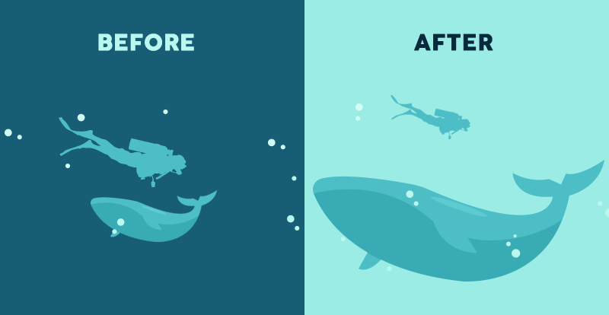
Bigger is better, right? While the classic adage is still up for debate, size is arguably the most effective way to emphasize visual elements. Simply put, larger elements draw greater attention than smaller elements.
It’s the precise reason why newspaper headlines appear in larger fonts, and major stories often have even larger headlines than articles on the rest of the page. In any design, larger elements—whether they be words or images—not only will be most noticeable, but they also will carry the strongest message.

Perspective Creates an Illusion of Depth
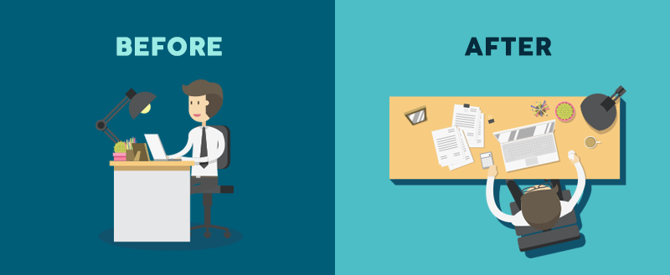
By utilizing perspective, designers can create an illusion of depth ranging from a few inches to several miles. Because we see similar illusions in the real world, we generally perceive larger objects as being closer than similar smaller objects and, therefore, they usually command attention before any other object on a page.

Color and Contrast Draw Attention
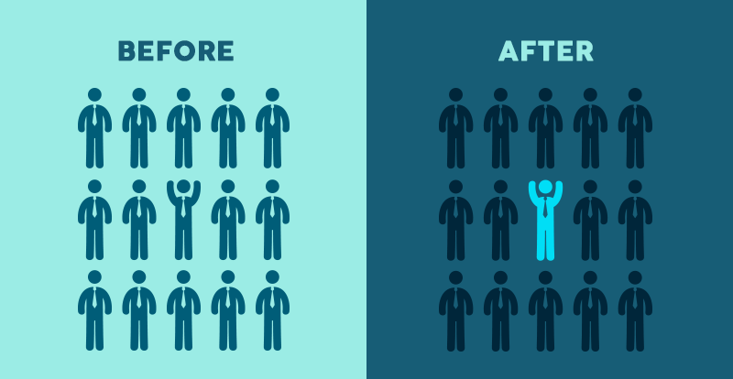
Just as larger elements are perceived as more important than smaller elements, bright colors usually draw greater attention than duller hues. For example, if a single sentence in a block of text is highlighted with a bright color, it immediately grabs readers’ attention.

Fonts Organize Design
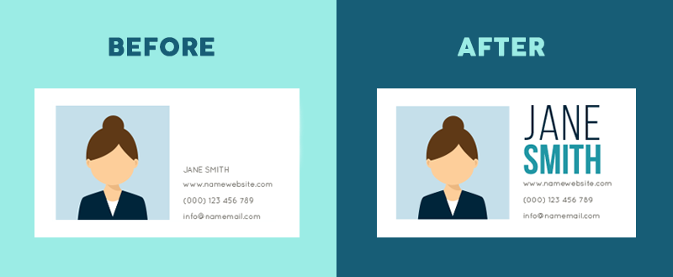
Think about an outline, a traditional resume or a table of contents. Generally, each is comprised of several sizes of type, with major headings in a larger point size than subsections and smaller details. Using a variety of type sizes not only emphasizes what’s most important, but also organizes the overall design of the document.
Typeface hierarchies can be created with text of various sizes, weights and spacing—or a combination of each element. Even if a single font is used throughout a design, varying its size and weight not only draws attention to more important elements, but creates an overall composition that is easy to read and understand.

Space Provides Emphasis and Movement
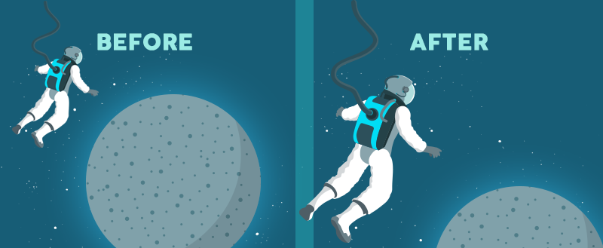

Rule of space
One of the most basic tenets of visual composition deals with what you leave out of your design. According to the Rule of Space, an aesthetically-pleasing design requires its fair share of clutter-free negative space, often referred to as “white space,” regardless of the design’s actual background color.
When arranging the elements of a composition, designers can use the space around the content to draw attention to particular elements—think of a single element on a blank page—or to send an entirely separate visual message, such as the hidden “arrow” found within the famous FedEx logo.
Strategic spacing can even draw viewers’ eyes across the page in a targeted sequence, by contributing to page-scanning patterns.

Proximity Suggests Relationships

Proximity, or where elements appear in relation to one another, is one of the most basic elements of composition. Simply speaking, placing related elements close together suggests to readers that they are, in fact, related.
Think of a white screen with a group of five dots on one side and a single dot on the other side. Our first assumption is always going to be that the five are, indeed, a group.

Negative Space Emphasizes

Just as grouping items near each other suggests their relation, including white space around elements singles them out as separate groups of information. Negative, empty space not only makes information easier for readers to digest by grouping it into compartments, but it also creates focus as it helps eyes zero in on individual items.

Alignment Directs Eyes

Alignment is part of the structure by which elements are placed in a design. It dictates that visual components, whether they be text or images, are not positioned arbitrarily throughout a composition. For example, a typical page of text is aligned to the left, so that objects share a left margin.

Odd-Numbered Groups Create Focus
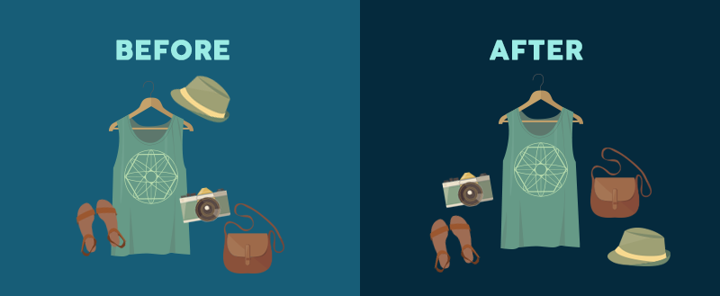
The Rule of Odds allows designers to emphasize particular images by placing them in the center of a group. By placing an equal number of neighboring objects on either side of the main focal point—thus creating an odd-numbered group—the result clearly points to the most important visual element, located in the center.

Repetition Unifies a Composition

Just as contrast emphasizes and draws attention to design elements, repetition creates unity, which boosts understanding and recognition.
Think of most published texts. The page designs are organized in such a way that body text is all one font, chapter headings are another and footnotes are a third different font—all consistent throughout the entire publication. This style repetition creates a cohesive work, recognized as a whole.
For a unified design, repeat some element—whether it’s font, color, shape or size—throughout the entire composition. Consistent styles help clearly define the visual hierarchy of any design.
Take, for example, the infographic in the introduction featuring our 12 visual-hierarchy principles. Repeating the same fonts and styles throughout the document clearly unifies the list and tells readers that each entry is part of a whole.
Repetition can also give elements new meaning. How often do you see blue underlined text stand out on a page? Enough that you instantly recognize the font as a hyperlink, right? Repeating this style in a design tells your audience where to click for more info. What other popular styles can give your design additional meaning?

Lines Suggest Movement
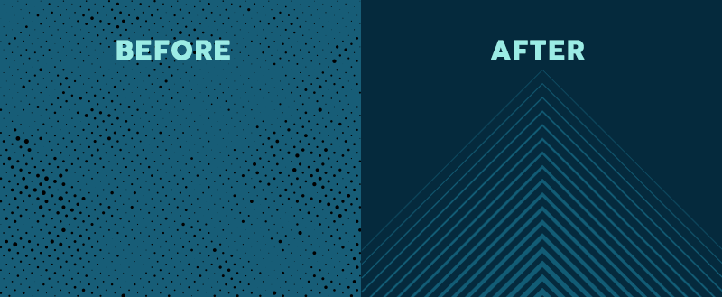
Movement is one of the most effective ways to attract viewers’ attention, especially when it’s implied within a still design. Lines are obviously efficient in pointing to items of emphasis—just think about an arrow—but they don’t have to physically appear on the page to do the trick.

Grids Organize a Design

The most effective designs are composed through some type of grid. The most typical grid is the classic modular composition of crossing vertical and horizontal lines.
Artists, photographers and graphic designers have long employed the rule of thirds to improve the overall balance of their compositions. The rule involves mentally dividing a composition into a grid composed of two horizontal and two vertical lines—or nine separate sections.

