LAB ASSIGNMENT – 10
Q1. Reverse Words Alphabetically: Read a sentence, use StringTokenizer to extract words, and print them in sorted (alphabetical) order.
Code:
import java.io.*;
import java.util.StringTokenizer;
public class program1{
public static void main(String[] args) throws IOException{
DataInputStream dis=new DataInputStream(System.in);
String s=dis.readLine();
StringTokenizer st=new StringTokenizer(s," ");
int cnt=st.countTokens();
String arr[]=new String[cnt];
int i=0;
while(st.hasMoreTokens()){
arr[i]=st.nextToken();
i++;
}
for(i=0;i<cnt-1;i++){
for(int j=i+1;j<cnt;j++){
if(arr[i].compareToIgnoreCase(arr[j])>0){
String temp=arr[i];
arr[i]=arr[j];
arr[j]=temp;
}
}
}
String ans="";
for (i=0;i<cnt;i++) {
String temp=arr[i];
ans+=temp+" ";
}
System.out.println(ans);
}
}
Output:
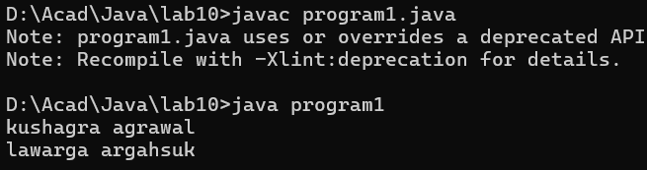
Q2. Find Duplicate Words: Read a sentence, split it using StringTokenizer, and identify which words appear more than once and remove.
Code:
import java.io.*;
import java.util.StringTokenizer;
public class program2{
public static void main(String[] args) throws IOException{
DataInputStream dis=new DataInputStream(System.in);
String s=dis.readLine();
StringTokenizer st=new StringTokenizer(s," ");
int cnt=st.countTokens();
String arr[]=new String[cnt];
int i=0;
while(st.hasMoreTokens()){
arr[i]=st.nextToken();
i++;
}
String ans="";
for(i=0;i<cnt-1;i++){
int freq=1;
for(int j=i+1;j<cnt;j++){
if(arr[j].equals(arr[i])){
freq++;
}
}
if(freq>1 && ans.indexOf(arr[i])==-1){
ans+=arr[i];
ans+=" ";
}
}
System.out.println(ans);
}
}
Output:
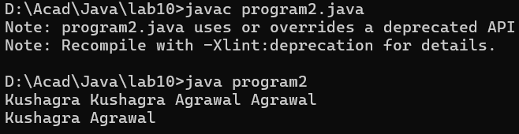
Q3. Capitalize First and Last Letter of Each Word: Read a line and output it with each word’s first letter capitalized.
Code:
import java.io.*;
import java.util.StringTokenizer;
public class program3{
public static void main(String[] args) throws IOException{
DataInputStream dis=new DataInputStream(System.in);
String s=dis.readLine();
StringTokenizer st=new StringTokenizer(s," ");
int cnt=st.countTokens();
String arr[]=new String[cnt];
int i=0;
while(st.hasMoreTokens()){
arr[i]=st.nextToken();
i++;
}
String ans="";
for(i=0;i<cnt;i++){
String temp=arr[i];
String first=temp.substring(0,1).toUpperCase();
int len=temp.length();
String last="";
if(len>2){last=temp.substring(len-1);}
last=last.toUpperCase();
String mid=temp.substring(1,len-1);
temp=first+mid+last;
ans+=temp;
ans+=" ";
}
System.out.println(ans);
}
}
Output:
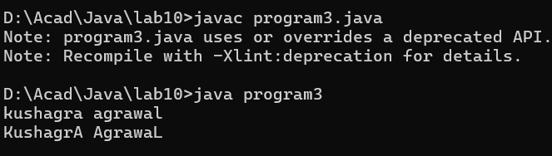
Q4 Word Replacement: Read a line and replace all occurrences of one word (given by the user) with another.
Code:
import java.io.*;
import java.util.StringTokenizer;
public class program4{
public static void main(String[] args) throws IOException{
DataInputStream dis=new DataInputStream(System.in);
String s=dis.readLine();
StringTokenizer st=new StringTokenizer(s," ");
int cnt=st.countTokens();
String arr[]=new String[cnt];
int i=0;
while(st.hasMoreTokens()){
arr[i]=st.nextToken();
i++;
}
System.out.println("Enter the word to replace ");
String oldword=dis.readLine();
System.out.println("Enter the new word");
String newword=dis.readLine();
if(s.indexOf(oldword)==-1){
System.out.println("your word is not found in above text");
}else{
String ans="";
for(i=0;i<cnt;i++){
if(arr[i].equals(oldword)
){
arr[i]=newword;
}
ans+=arr[i];
ans+=" ";
}
System.out.println(ans);
}
}
}
Output:


