Definition
  - General anaesthetics (GAs) are drugs which produce reversible loss of all sensation and consciousness. General anesthesia usually uses a combination of intravenous drugs and inhaled gasses (anesthetics).The main features of general anaesthesia are:
→ Loss of all sensation, especially pain
→ Sleep (unconsciousness) and amnesia
→ Immobility and muscle relaxation
→ Abolition of somatic and autonomic reflexes.

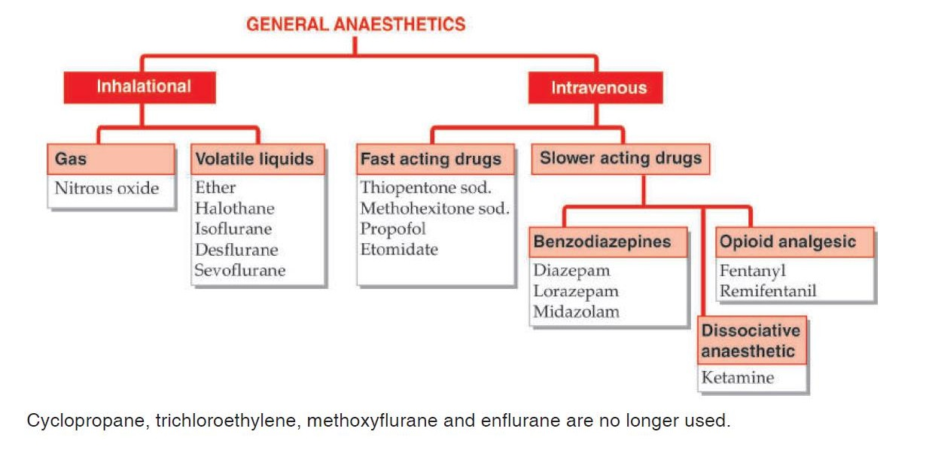
Classification(also see Pharmaceutical chemistry CH-5)
- Pharmacological Action
- Anesthesia involves three main changes:
  - Unconsciousness
  - Loss of response to pain
  - Loss of motor reflexes
- In high doses all agents can cause death by cardiovascular and respiratory depression via the brain stem
- At the cellular level, anesthetics affect synaptic transmission through decreased transmitter release, rather than decreasing axonal conduction
- Though all parts of the CNS can be affected, loss of consciousness is mainly through the inhibition of the reticular formation and amnesia through the hippocampus
- Most anesthetics, with the exception of ketamine, cause similar neurophysiological effects. The difference lies in their potency, duration of action, toxicity
- Most anesthetics, excepting ketamine & opioids, depress the cardiovascular system directly and, indirectly, through the CNS
- Nitrous oxide (N2O)-
  - Nitrous oxide is generally used as a carrier and adjuvant to other anaesthetics.
  - A mixture of 70% N2O + 25–30% O2 + 0.2–2% another potent anaesthetic is employed for most surgical procedures.
  - Because N2O has little effect on respiration, heart and BP: breathing and circulation are better maintained with the mixture than with the potent anaesthetic given alone in full doses.
  - Nitrous oxide is a good analgesic;
  - Muscle relaxation is minimal
  - Second gas effect and diffusion hypoxia occur with N2O only

  - It is nontoxic to liver, kidney and brain.
  - However, prolonged N2O anaesthesia has the potential to depress bone marrow and cause peripheral neuropathy,
- Diethyl ether-
  - Ether is a potent anaesthetic, produces good analgesia and marked muscle relaxation by reducing ACh output from motor nerve endings
  - Respiration and BP are generally well maintained
  - Ether is not used now, except in peripheral and resource-poor areas, because of its unpleasant and inflammable properties.
- Halothane (FLUOTHANE
  - It is not a good analgesic or muscle relaxant,
  - Halothane causes direct depression of myocardial contractility by reducing intracellular Ca2+ concentration
  - Halothane causes relatively greater depression of respiration
  - Urine formation is decreased during halothane anaesthesia—primarily due to low g.f.r. as a result of fall in BP
- Isoflurane (SOFANE, FORANE, ISORANE
  - This is fluorinated anaesthetic introduced in 1981
  - Magnitude of fall in BP is similar to that with halothane
  - Heart rate is increased.
  - Respiratory depression is prominent and assistance is usually needed to avoid hypercarbia.

Desflurane
  - Rapid induction sometimes causes brief sympathetic stimulation and tachycardia which may be risky in those with cardiovascular disease. The degree of respiratory depression, muscle relaxation, vasodilatation and fall in BP are similar to that with isoflurane.

Thiopentone sod.
  - CNS depressants
  - Thiopentone is a poor analgesic
  - It is a weak muscle relaxant;
  - does not irritate air passages.
  - Respiratory depression with inducing doses of thiopentone is generally marked; transient apnoea can occur.
  - The BP falls immediately after injection, mainly due to vasodilatation, but recovers rapidly.
  - Cardiac contractility is reduced, but reflex tachycardia occurs.
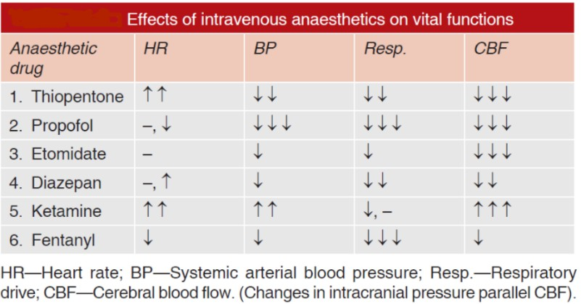

COMPLICATIONS OF GENERAL ANAESTHESIA(not in course but used as pharmacological action )
- During anaesthesia
  - Respiratory depression and hypercarbia. This is more prominent with isoflurane;
  - Salivation, respiratory secretions and depressed mucociliary function in the airway. This is less problematic with modern anaesthetics.

  - Cardiac arrhythmias, asystole.
  - Fall in BP.
  - Aspiration of acidic gastric contents.
  - Laryngospasm and asphyxia.

Doses-
  - Thiopantane sodium - Injected i.v. (3–5 mg/kg) as a 2.5% solution, thiopentone sod. produces unconsciousness in 15–20 sec.
  - Propofol - It is an oily liquid employed as a 1% emulsion. 2 mg/kg bolus i.v. for induction; 100–200
μg/kg/min for maintenance.
  - Etomidate It is induction anaesthetic (0.2–0.5 mg/kg)
  - Diazepam: 0.2–0.5 mg/kg by slow undiluted injection in a running i.v. drip:
  - Lorazepam- Dose: 2–4 mg (0.04 mg/kg) i.v.
  - Ketamine- A dose of 1–2 (average 1.5) mg/kg i.v. or 3–5 mg/kg i.m. produces the above effects within a minute,
  - Fentanyl- After i.v. fentanyl (2–4 μg/kg) the patient remains drowsy but conscious
  - Remifentanil- 0.5 mg/kg/min i.v. infusion, followed by 0.25- 0.5 mg/kg/min.

Indications:
- Extreme anxiety and fear.
- Adults or children who have mental or physical disabilities, senile patients, or disoriented patients.
- Age-infants and children.
- Short, traumatic procedures.
- Prolonged traumatic procedures.

Contraindications-
  - Pregnant women
  - Patient with glaucoma and myasthenia gravis
  - Children with severe mental impairment
  - Alcoholics
  - Hypersensitivity
  - Increased intracranial pressure
  - ASA III patients (American Society of Anaesthesiologists =ASA)

