Memory management:
- In a multiprogramming computer, the Operating System resides in a part of memory, and the rest is used by multiple processes.
- The task of subdividing the memory among different processes is called Memory Management.
- Memory management is a method in the operating system to manage operations between main memory and disk during process execution. The main aim of memory management is to achieve efficient utilization of memory.
Swapping:
- To increase CPU utilization in multiprogramming, a memory management scheme known as swapping can be used.
- Swapping is the process of bringing a process into memory and then temporarily copying it to the disc after it has run for a while. The purpose of swapping in an operating system is to access data on a hard disc and move it to RAM so that application programs can use it.
- The concept of swapping has divided into two more concepts: Swap-in and Swap-out
Swap-out is a technique for moving a process from RAM to the hard disc.
Swap-in is a method of transferring a program from a hard disc to main memory, or RAM.

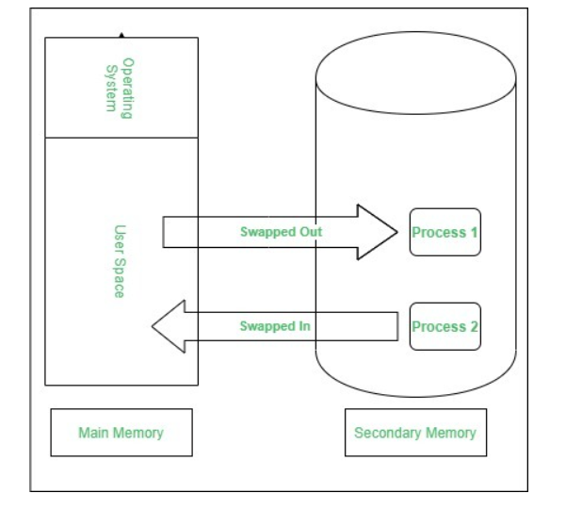

Contiguous memory allocation:
- Contiguous memory allocation is one of these memory allocation strategies.
- We use this strategy to allocate contiguous blocks of memory to each process, as the name suggests.
- Therefore, we allot a continuous segment from the entirely empty area to the process based on its size whenever a process requests to reach the main memory.

What is Paging?
Paging is a storage mechanism used in OS to retrieve processes from secondary storage to the main memory as pages. The primary concept behind paging is to break each process into individual pages. Thus the primary memory would also be separated into frames.
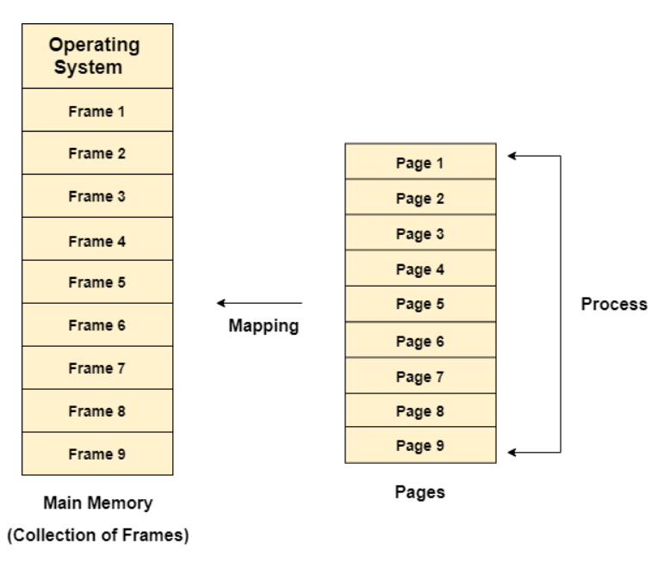
What is segmentation?
In Operating Systems, Segmentation is a memory management technique in which the memory is divided into the variable size parts. Each part is known as a segment which can be allocated to a process.
The details about each segment are stored in a table called a segment table. Segment table is stored in one (or many) of the segments.
Segment table contains mainly two information about segment:
- Base: It is the base address of the segment
- Limit: It is the length of the segment.


